* 1. Sensitivity Analysis
* 2. Time profiles and residual plots
  + 2.1. Time profiles and residual plots for Larson 2013 8y-18y 400mg FCT meal
  + 2.2. Time profiles and residual plots for Filmcoated_tablet_400mg_sd
  + 2.3. Residuals across all simulations
* 3. Demography

# 1. Sensitivity Analysis

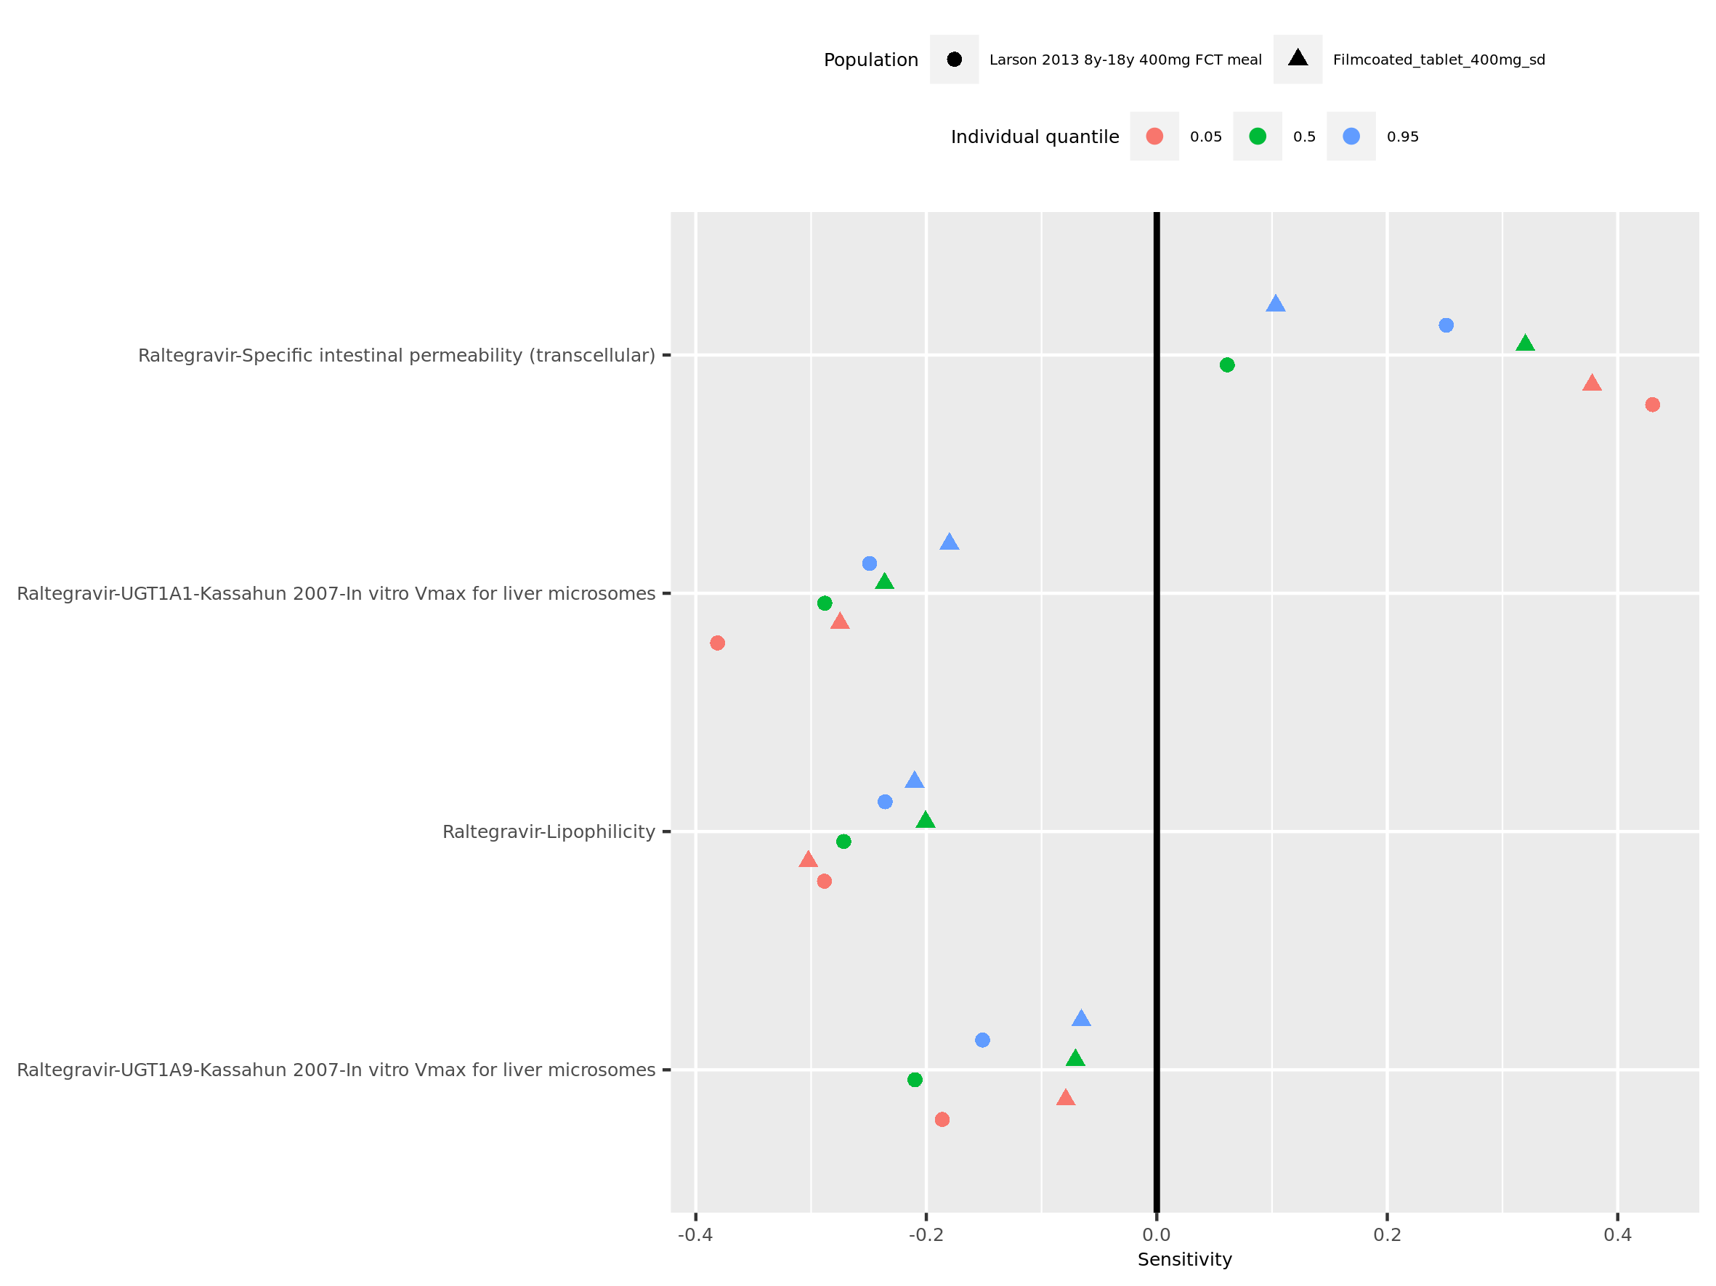

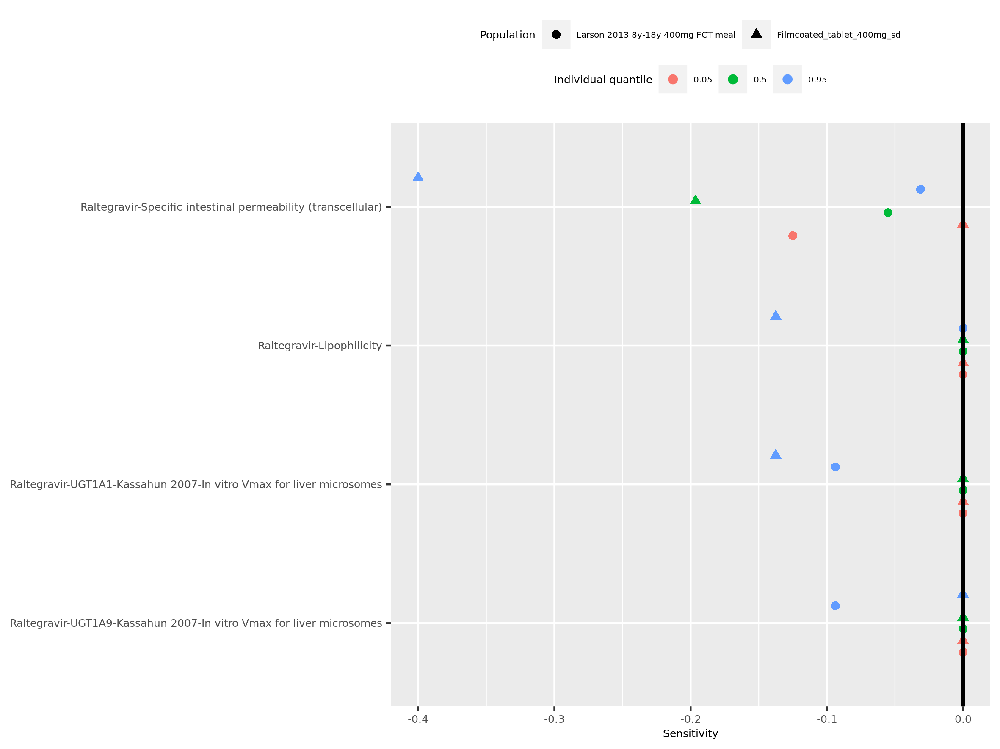

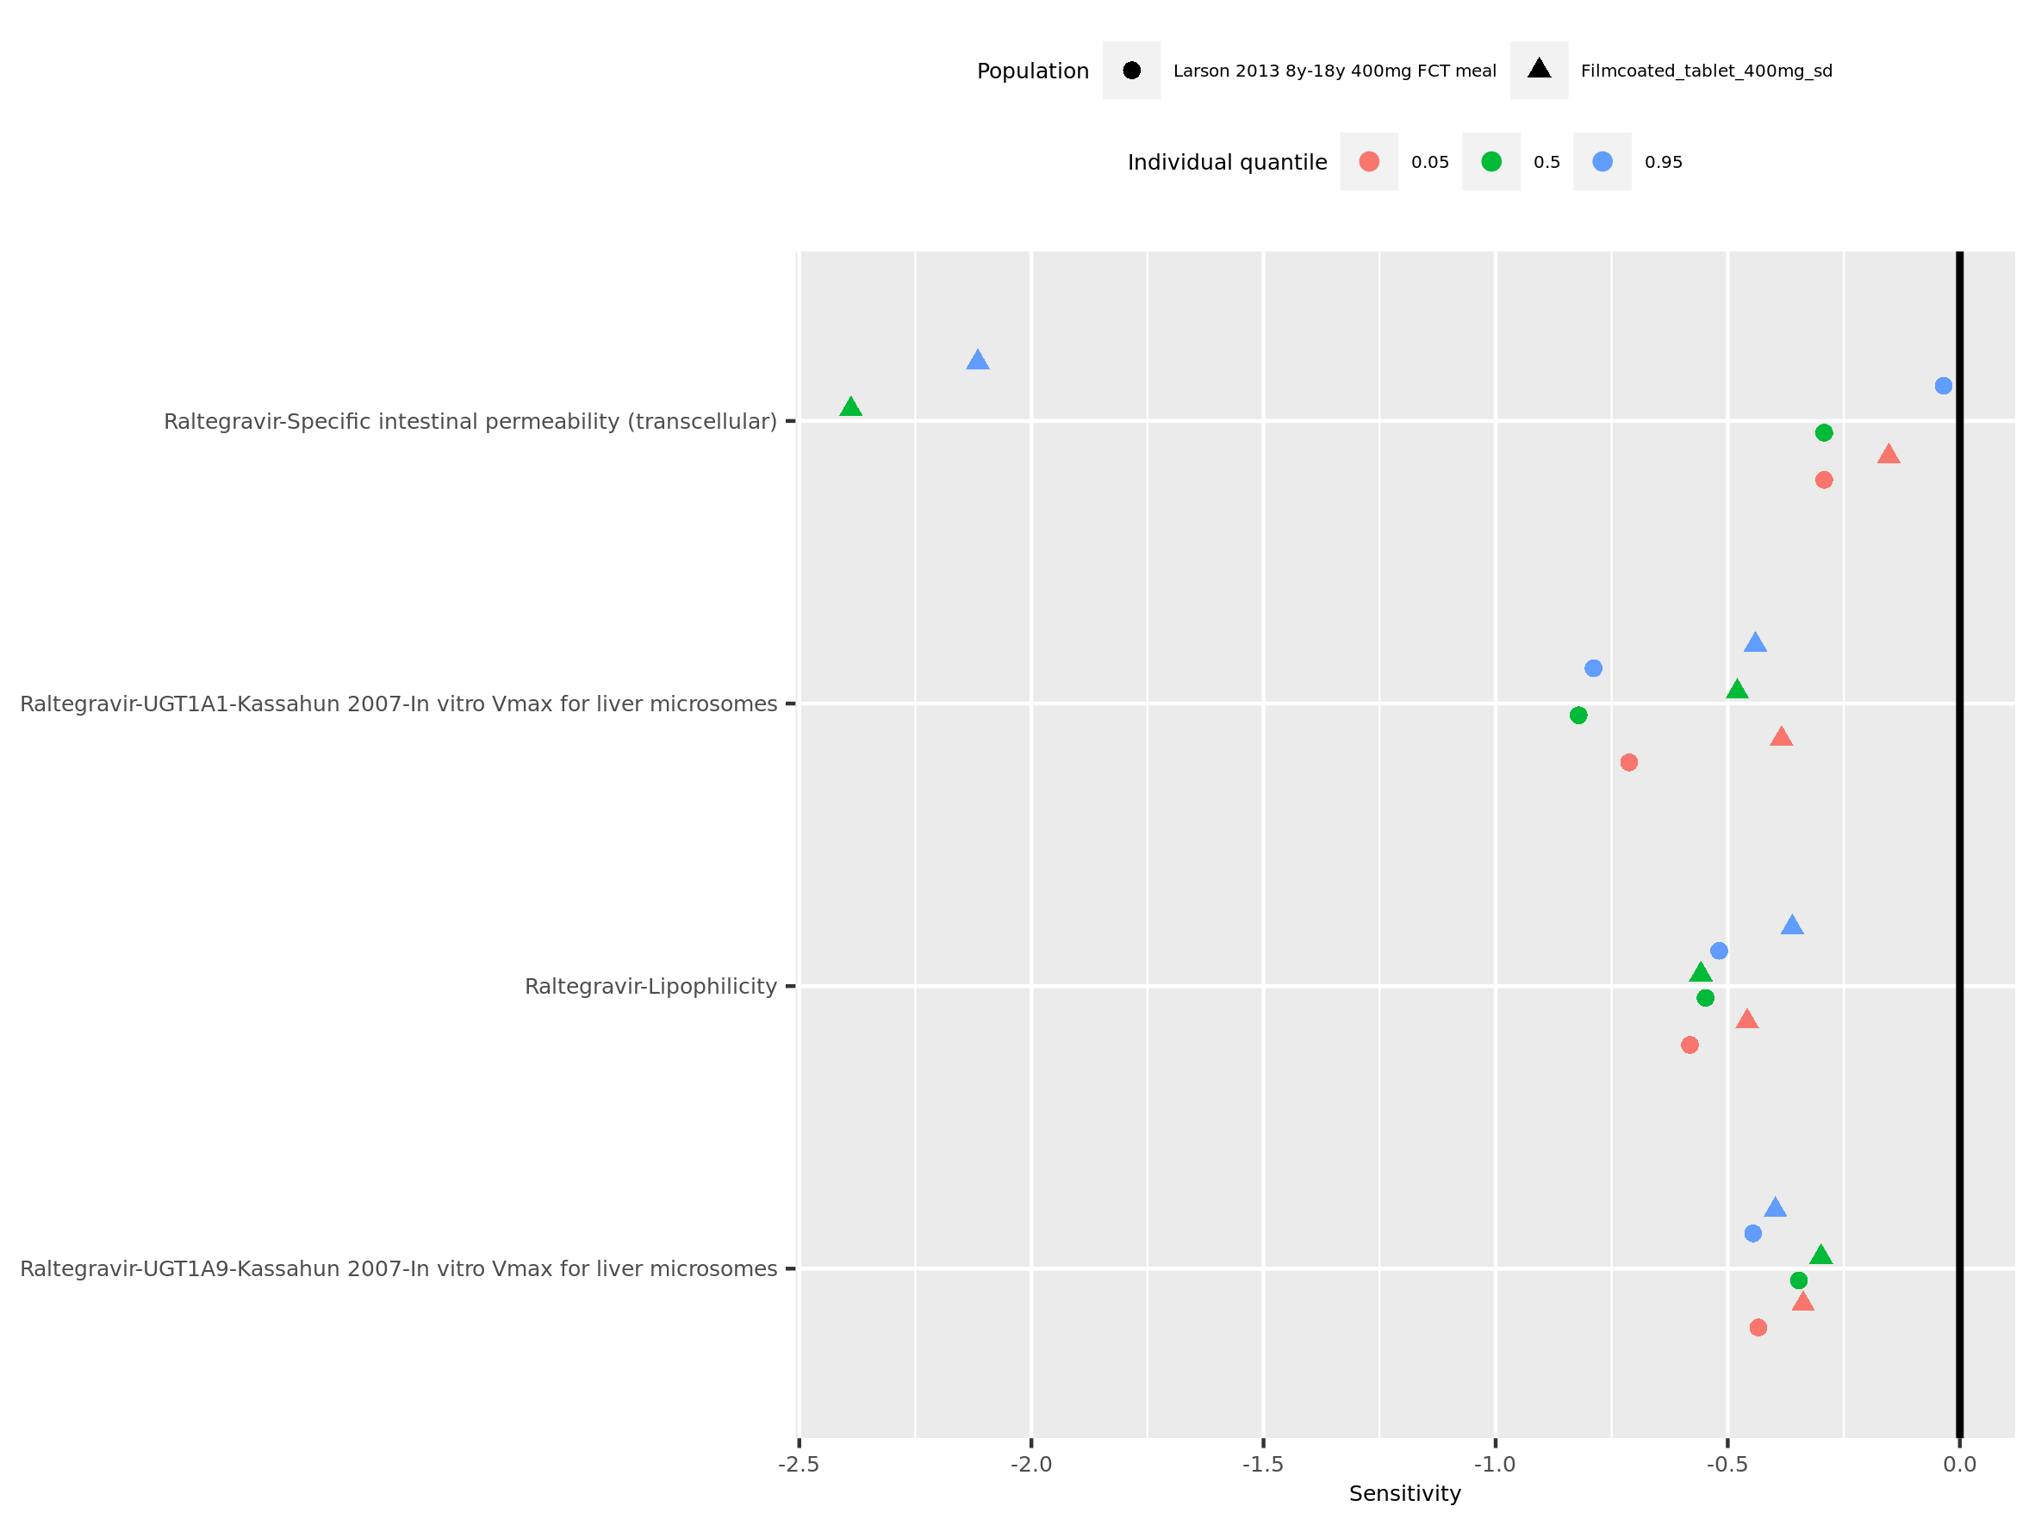

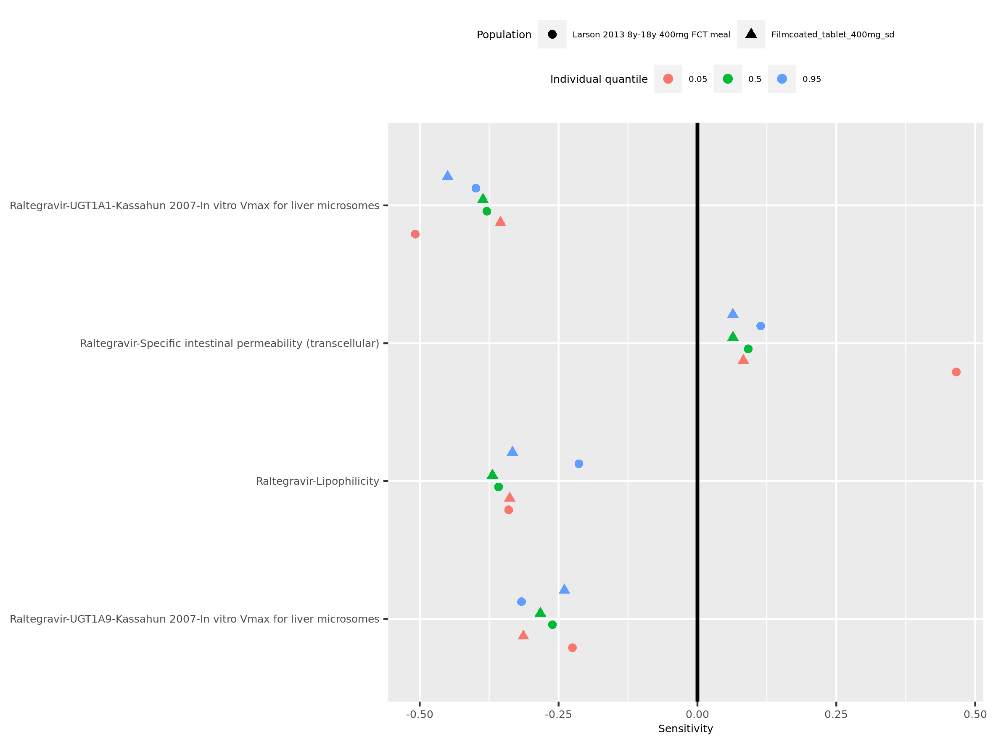

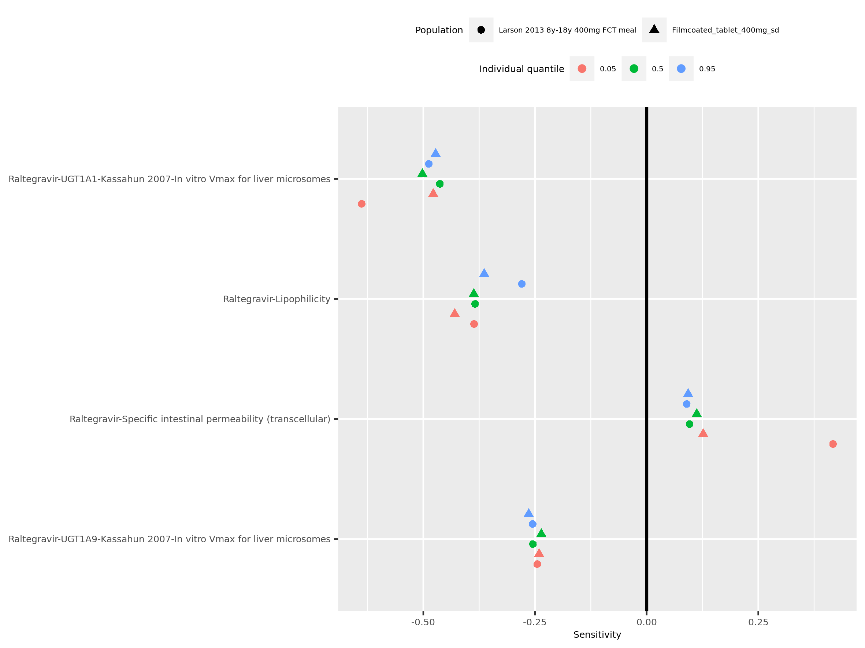

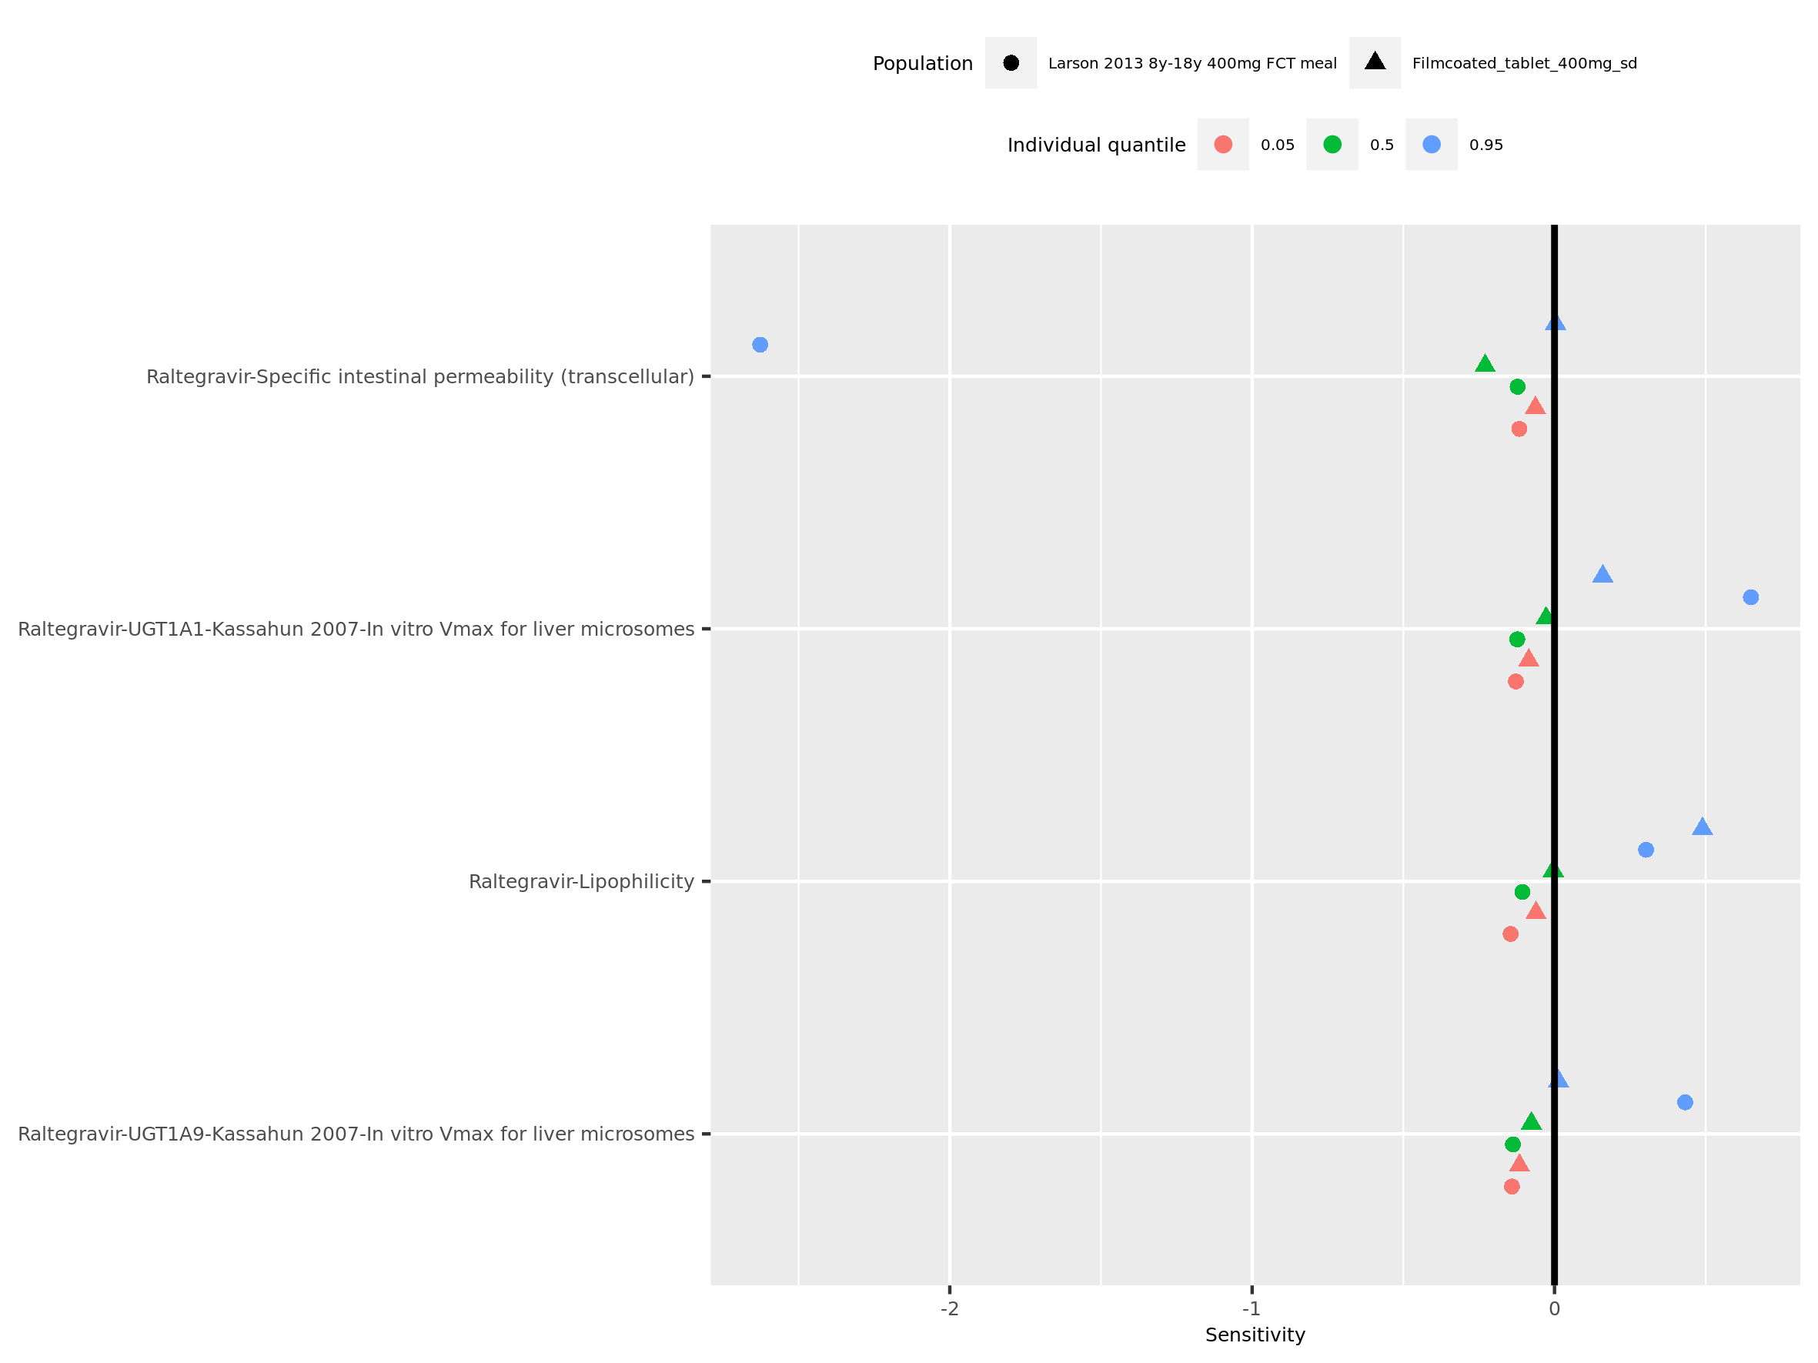

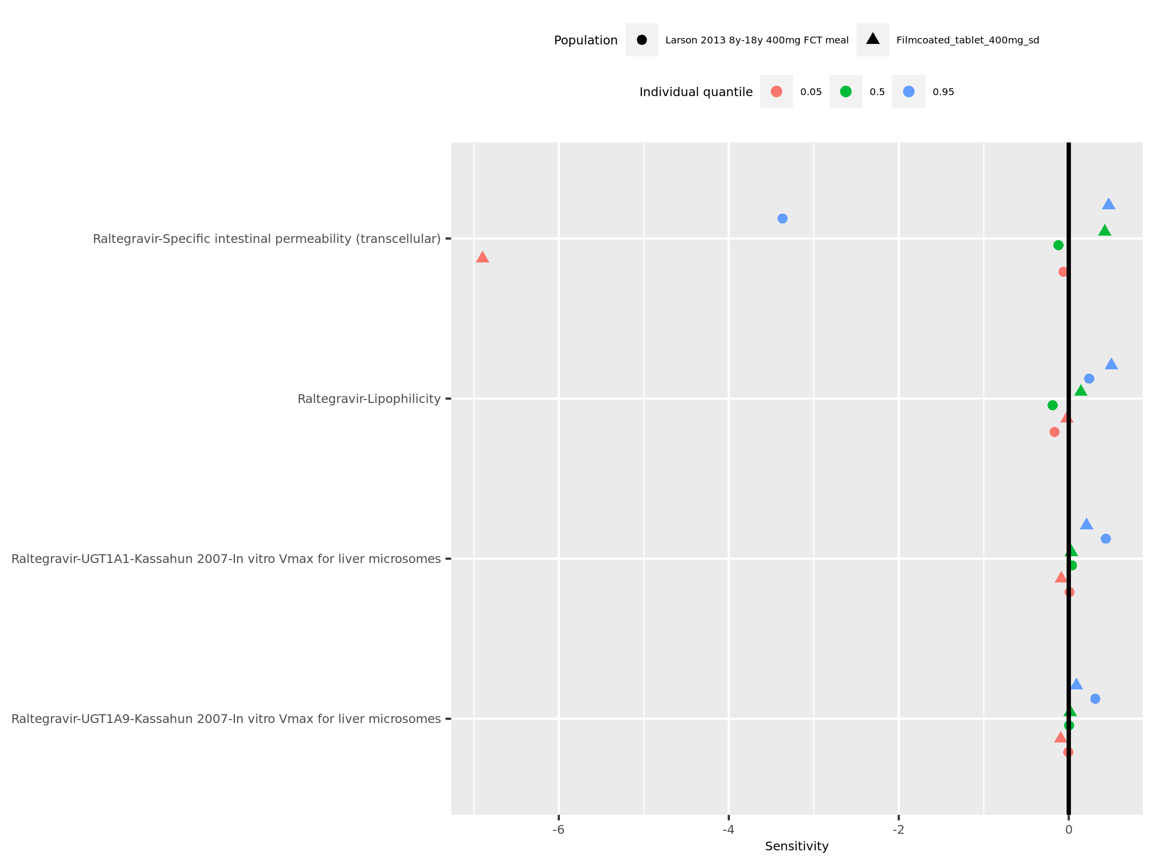

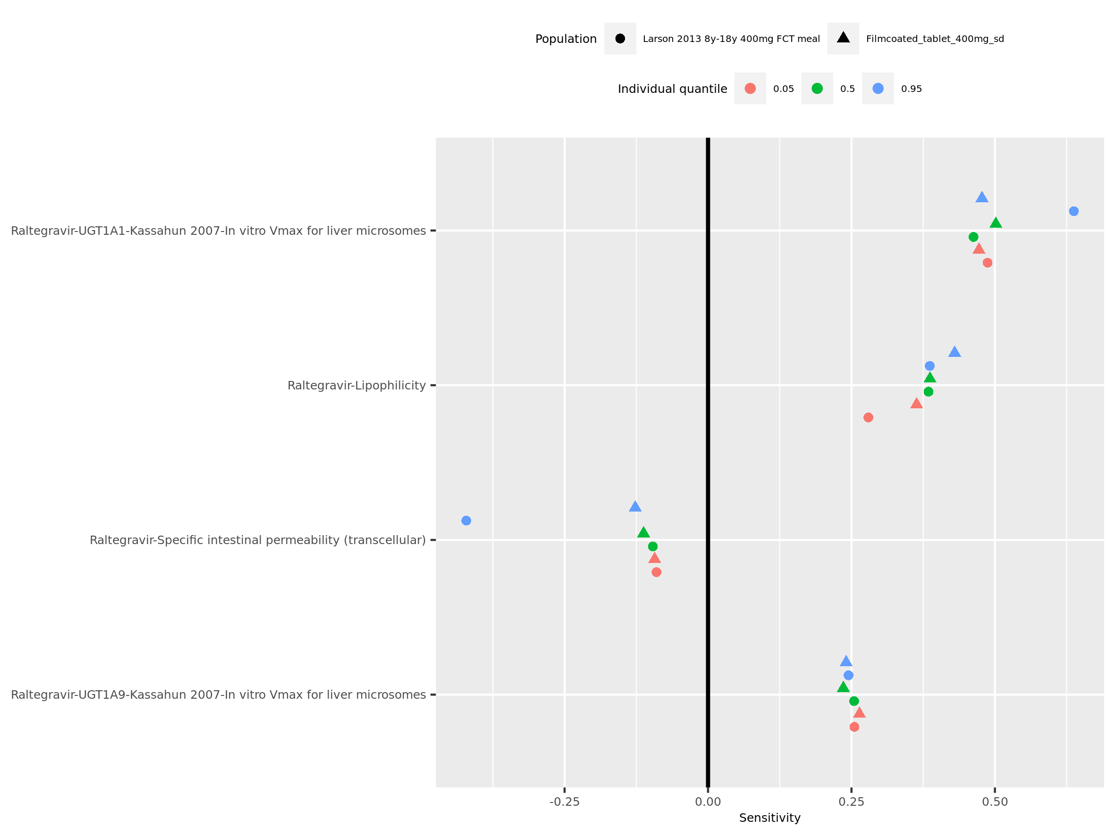

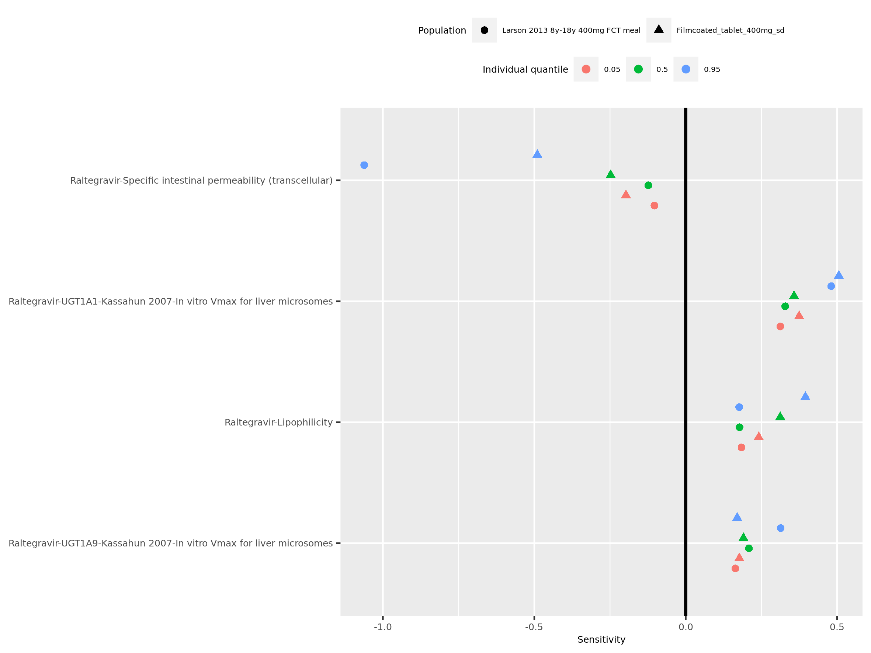

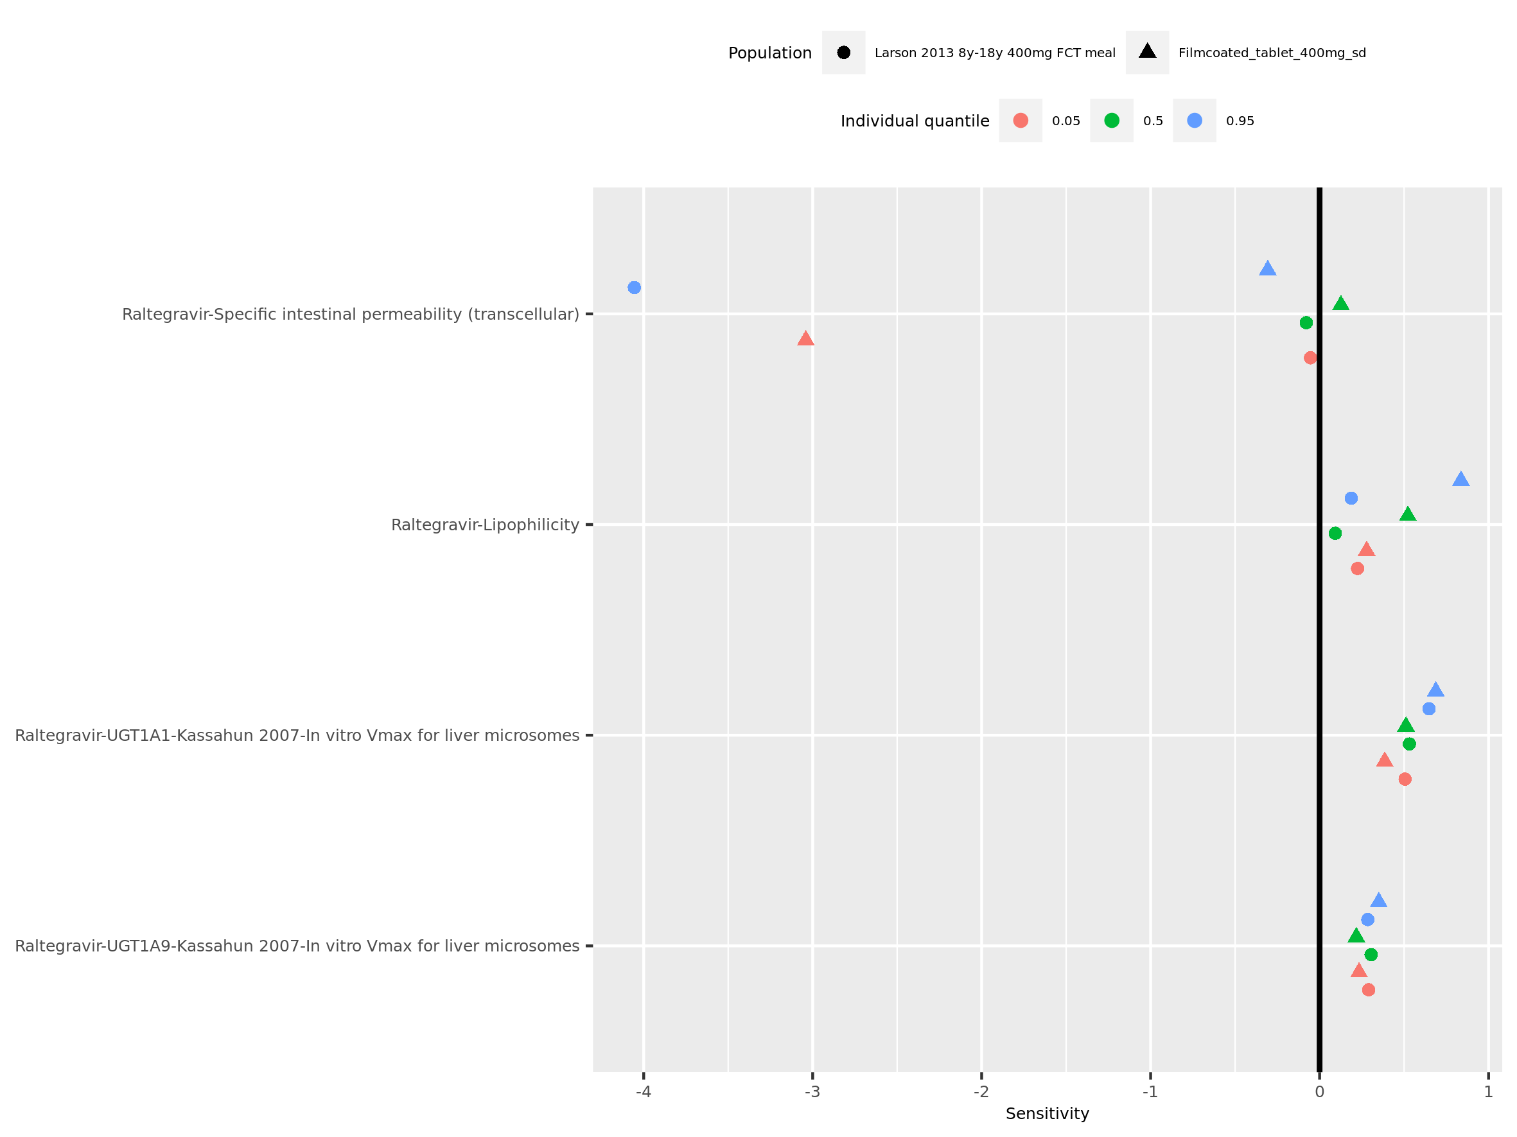

# 2. Time profiles and residual plots

## 2.1. Time profiles and residual plots for Larson 2013 8y-18y 400mg FCT meal

Figure 1: Time profiles of Larson 2013 8y-18y 400mg FCT meal for Larson 2013 8-18y meal. Data source: Data/Raltegravir_PK.txt. Time profiles are plotted in a linear scale.

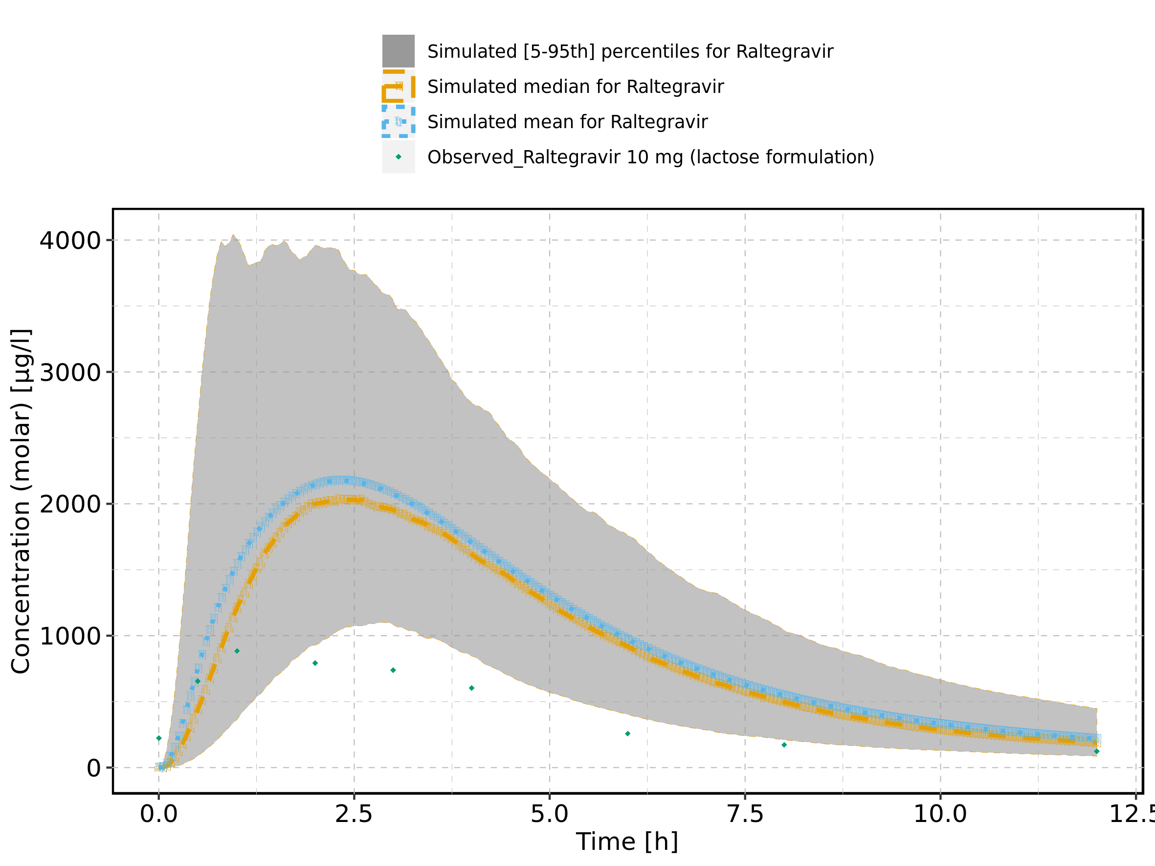

Figure 2: Time profiles of Larson 2013 8y-18y 400mg FCT meal for Larson 2013 8-18y meal. Data source: Data/Raltegravir_PK.txt. Time profiles are plotted in a logarithmic scale.

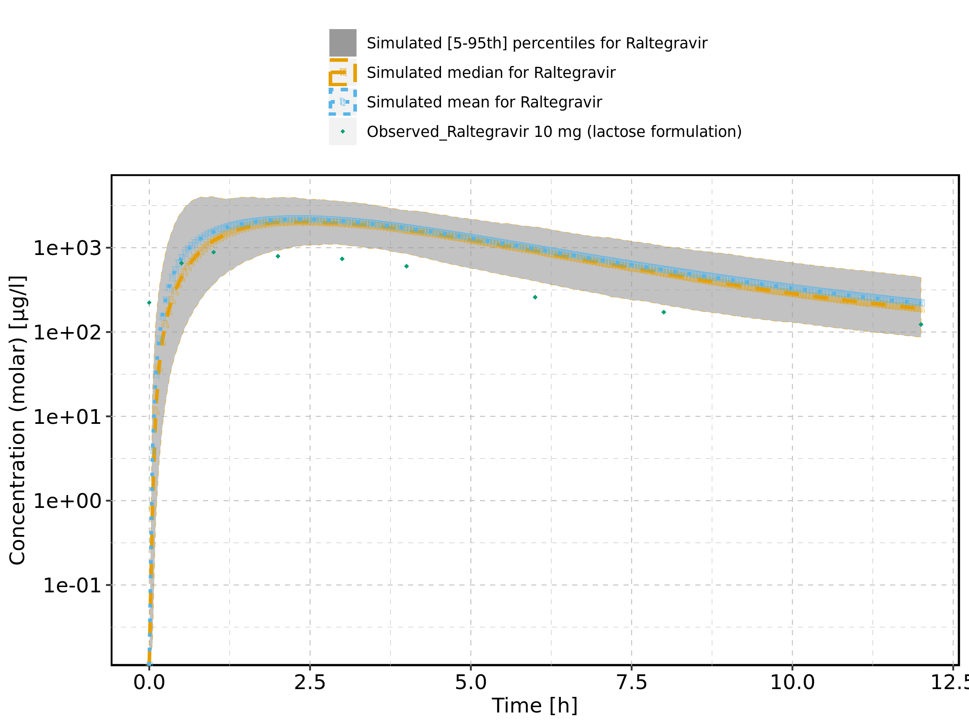

Figure 3: Predicted vs observed of Larson 2013 8y-18y 400mg FCT meal for Larson 2013 8-18y meal. Data source: Data/Raltegravir_PK.txt. Predictions and observations are plotted in a linear scale.

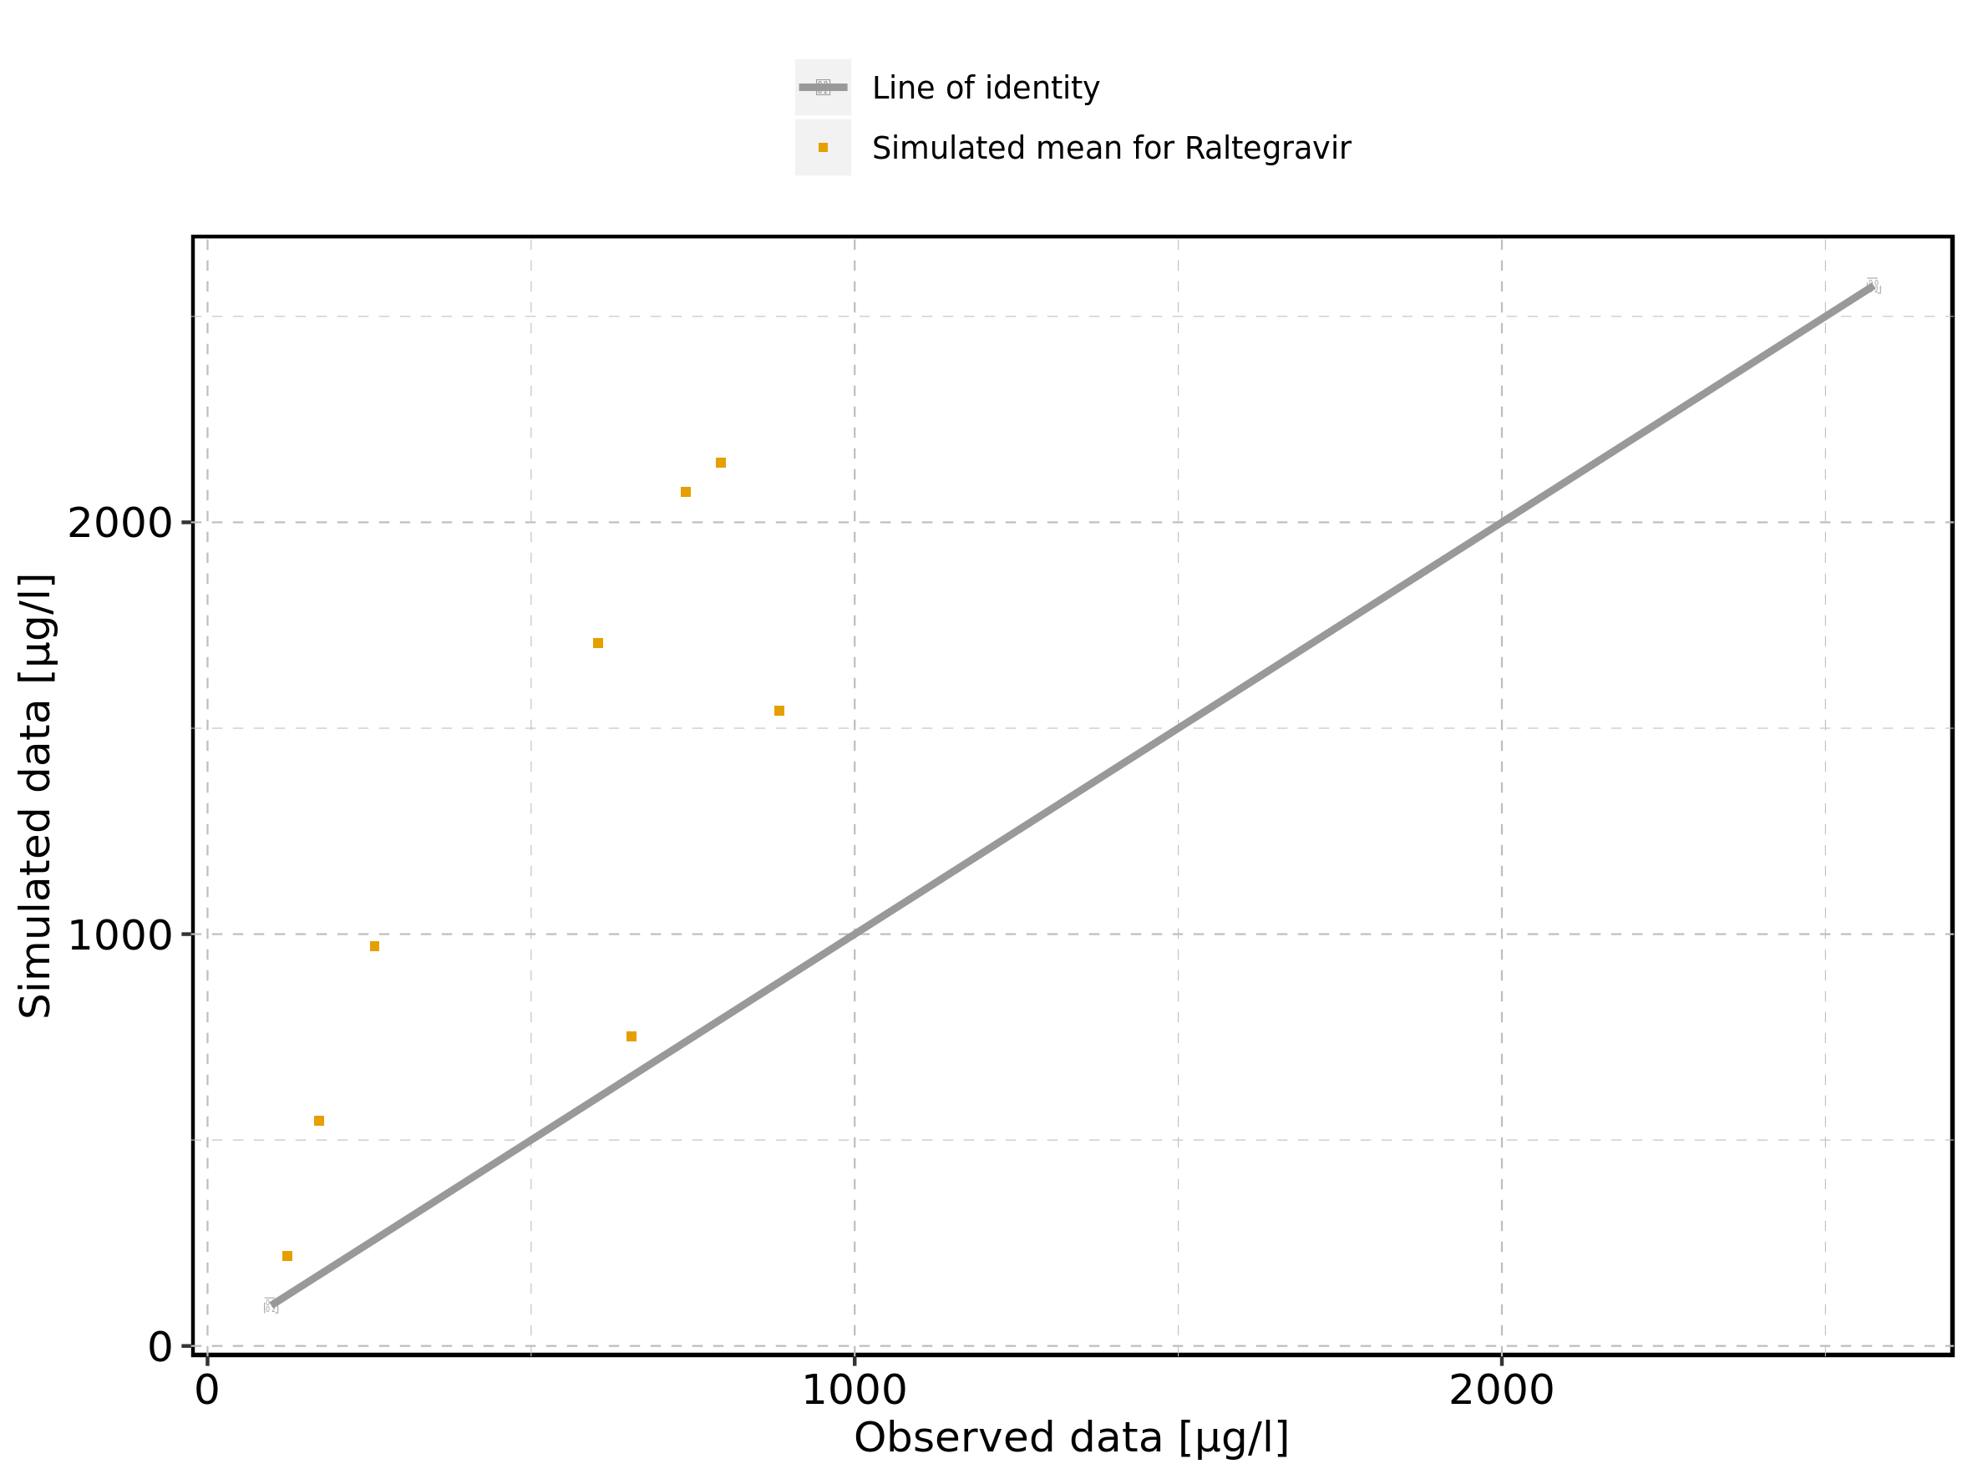

Figure 4: Predicted vs observed of Larson 2013 8y-18y 400mg FCT meal for Larson 2013 8-18y meal. Data source: Data/Raltegravir_PK.txt. Predictions and observations are plotted in a logarithmic scale.

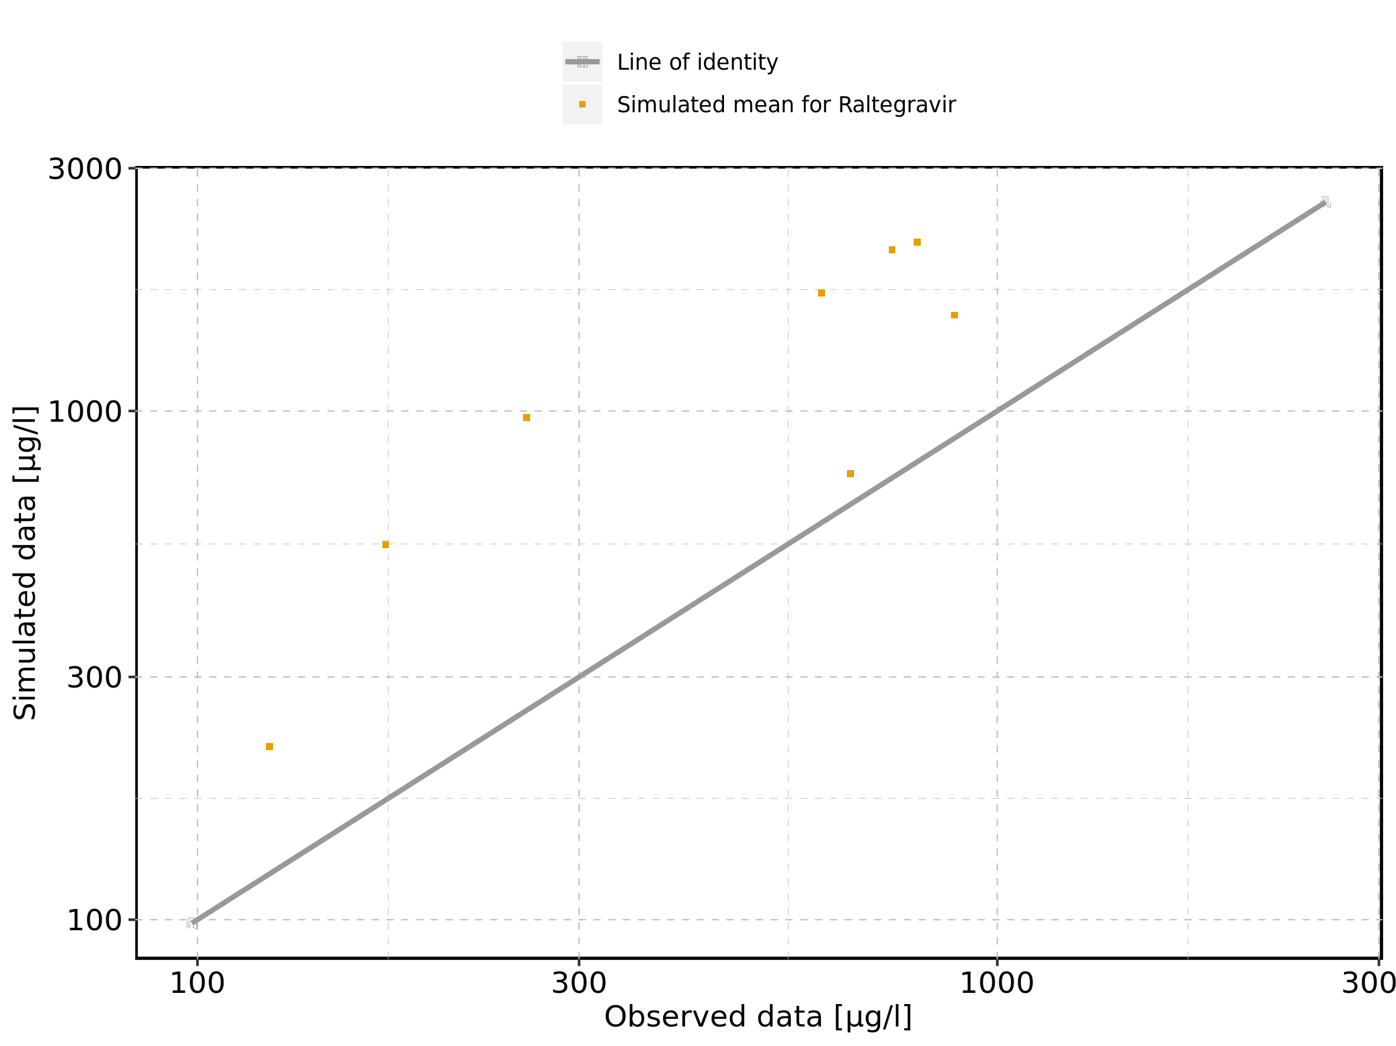

Figure 5: Logarithmic residuals vs predicted values of Larson 2013 8y-18y 400mg FCT meal for Larson 2013 8-18y meal. Data source: Data/Raltegravir_PK.txt.

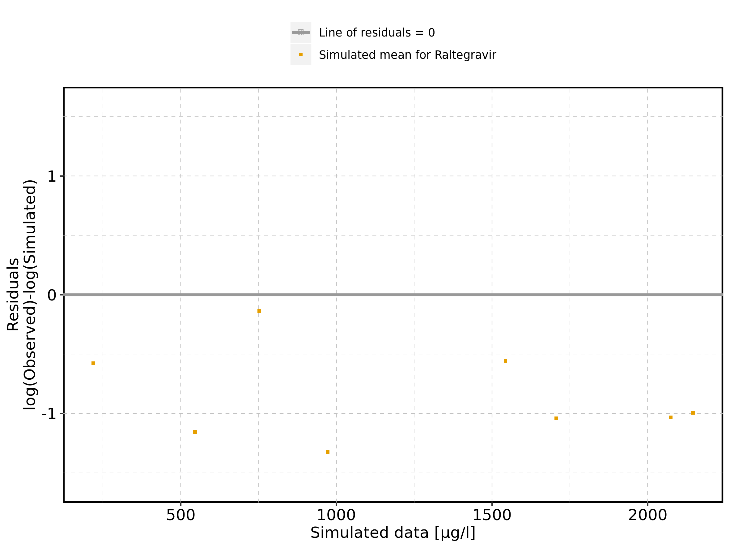

Figure 6: Logarithmic residuals vs time of Larson 2013 8y-18y 400mg FCT meal for Larson 2013 8-18y meal. Data source: Data/Raltegravir_PK.txt.

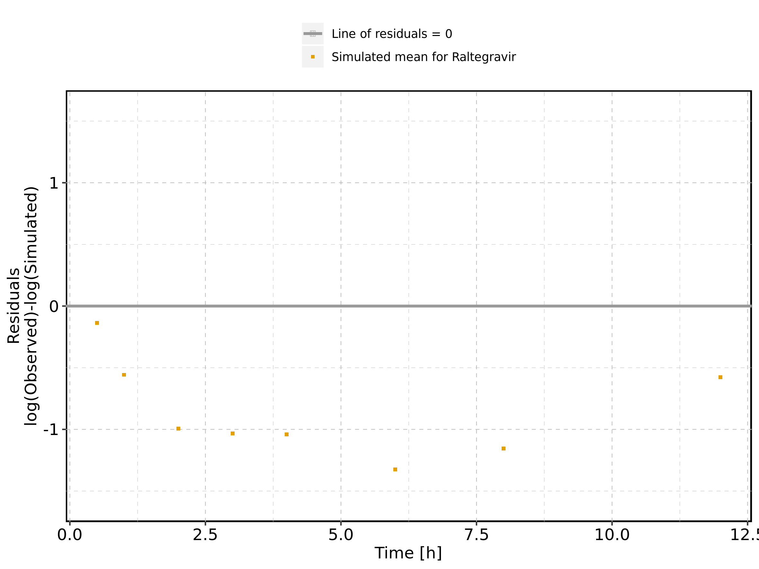

Figure 7: Logarithmic residuals distribution of Larson 2013 8y-18y 400mg FCT meal for Larson 2013 8-18y meal. Data source: Data/Raltegravir_PK.txt.

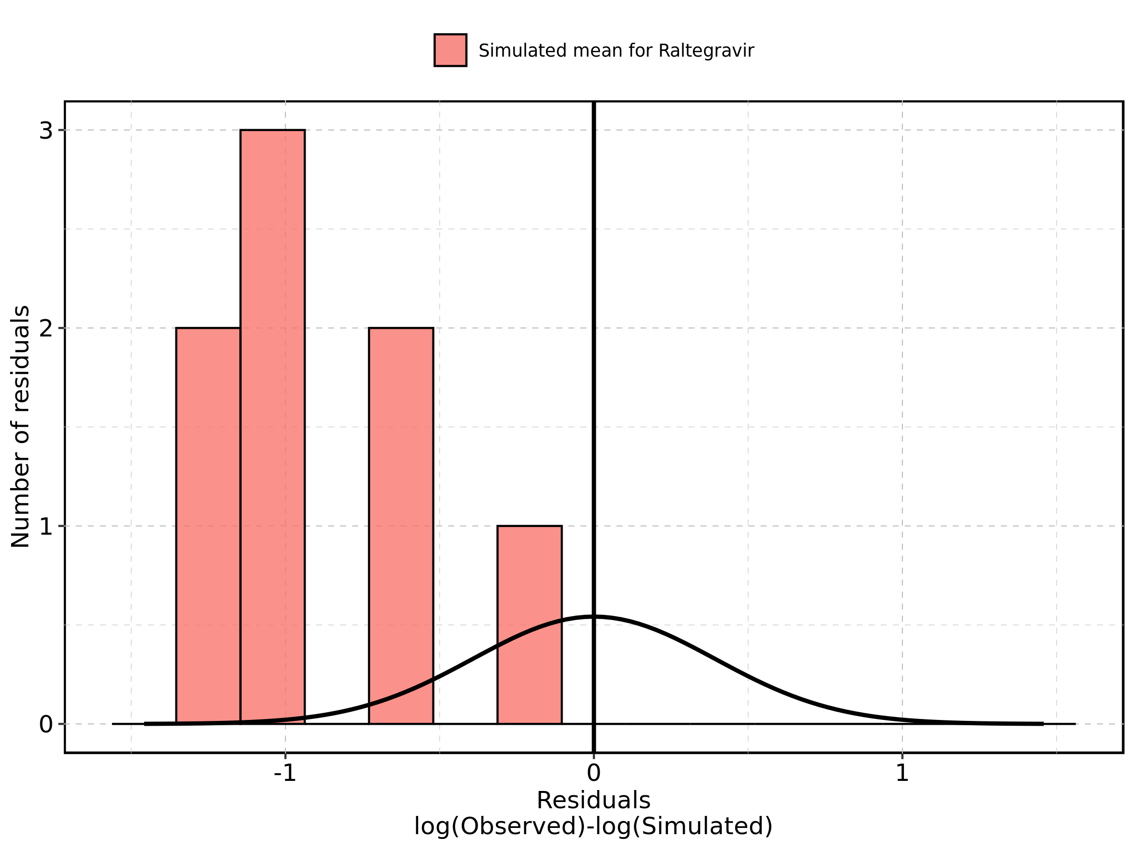

Figure 8: Logarithmic residuals of Larson 2013 8y-18y 400mg FCT meal for Larson 2013 8-18y meal as quantile-quantile plot. Data source: Data/Raltegravir_PK.txt.

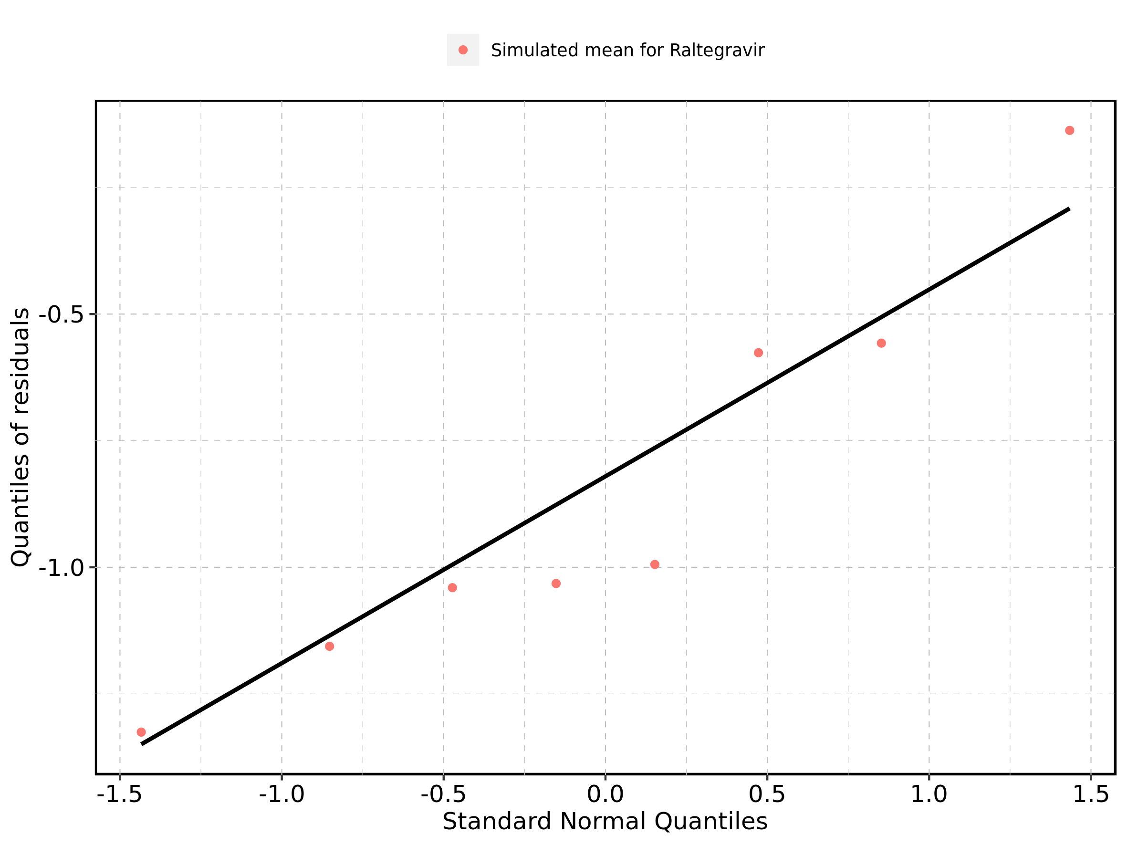

## 2.2. Time profiles and residual plots for Filmcoated_tablet_400mg_sd

Figure 9: Time profiles of Filmcoated_tablet_400mg_sd for Raltegravir 400mg filmcoated tablet. Data source: Data/Raltegravir_PK.txt. Time profiles are plotted in a linear scale.

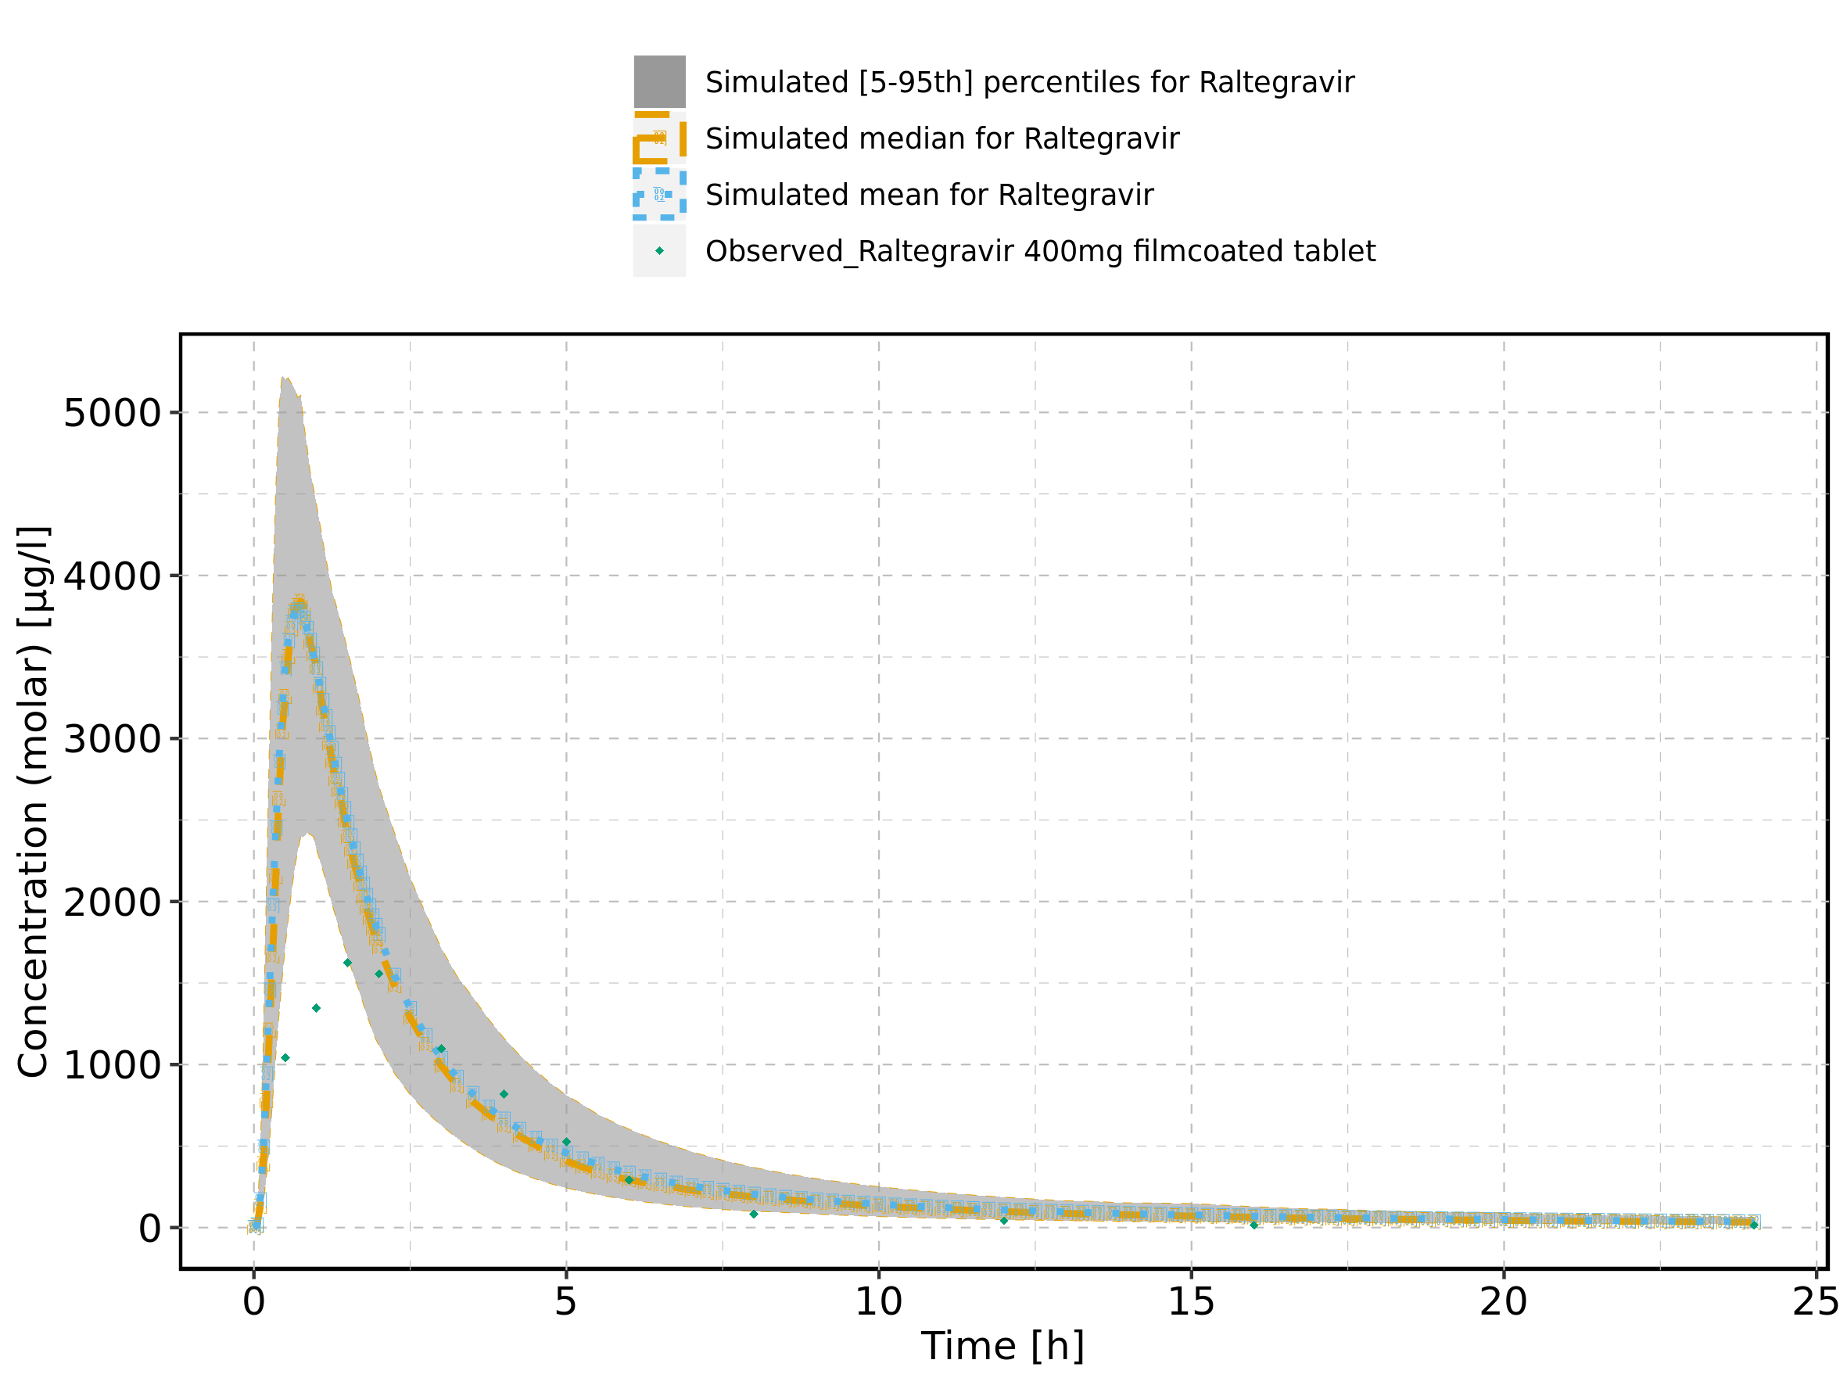

Figure 10: Time profiles of Filmcoated_tablet_400mg_sd for Raltegravir 400mg filmcoated tablet. Data source: Data/Raltegravir_PK.txt. Time profiles are plotted in a logarithmic scale.

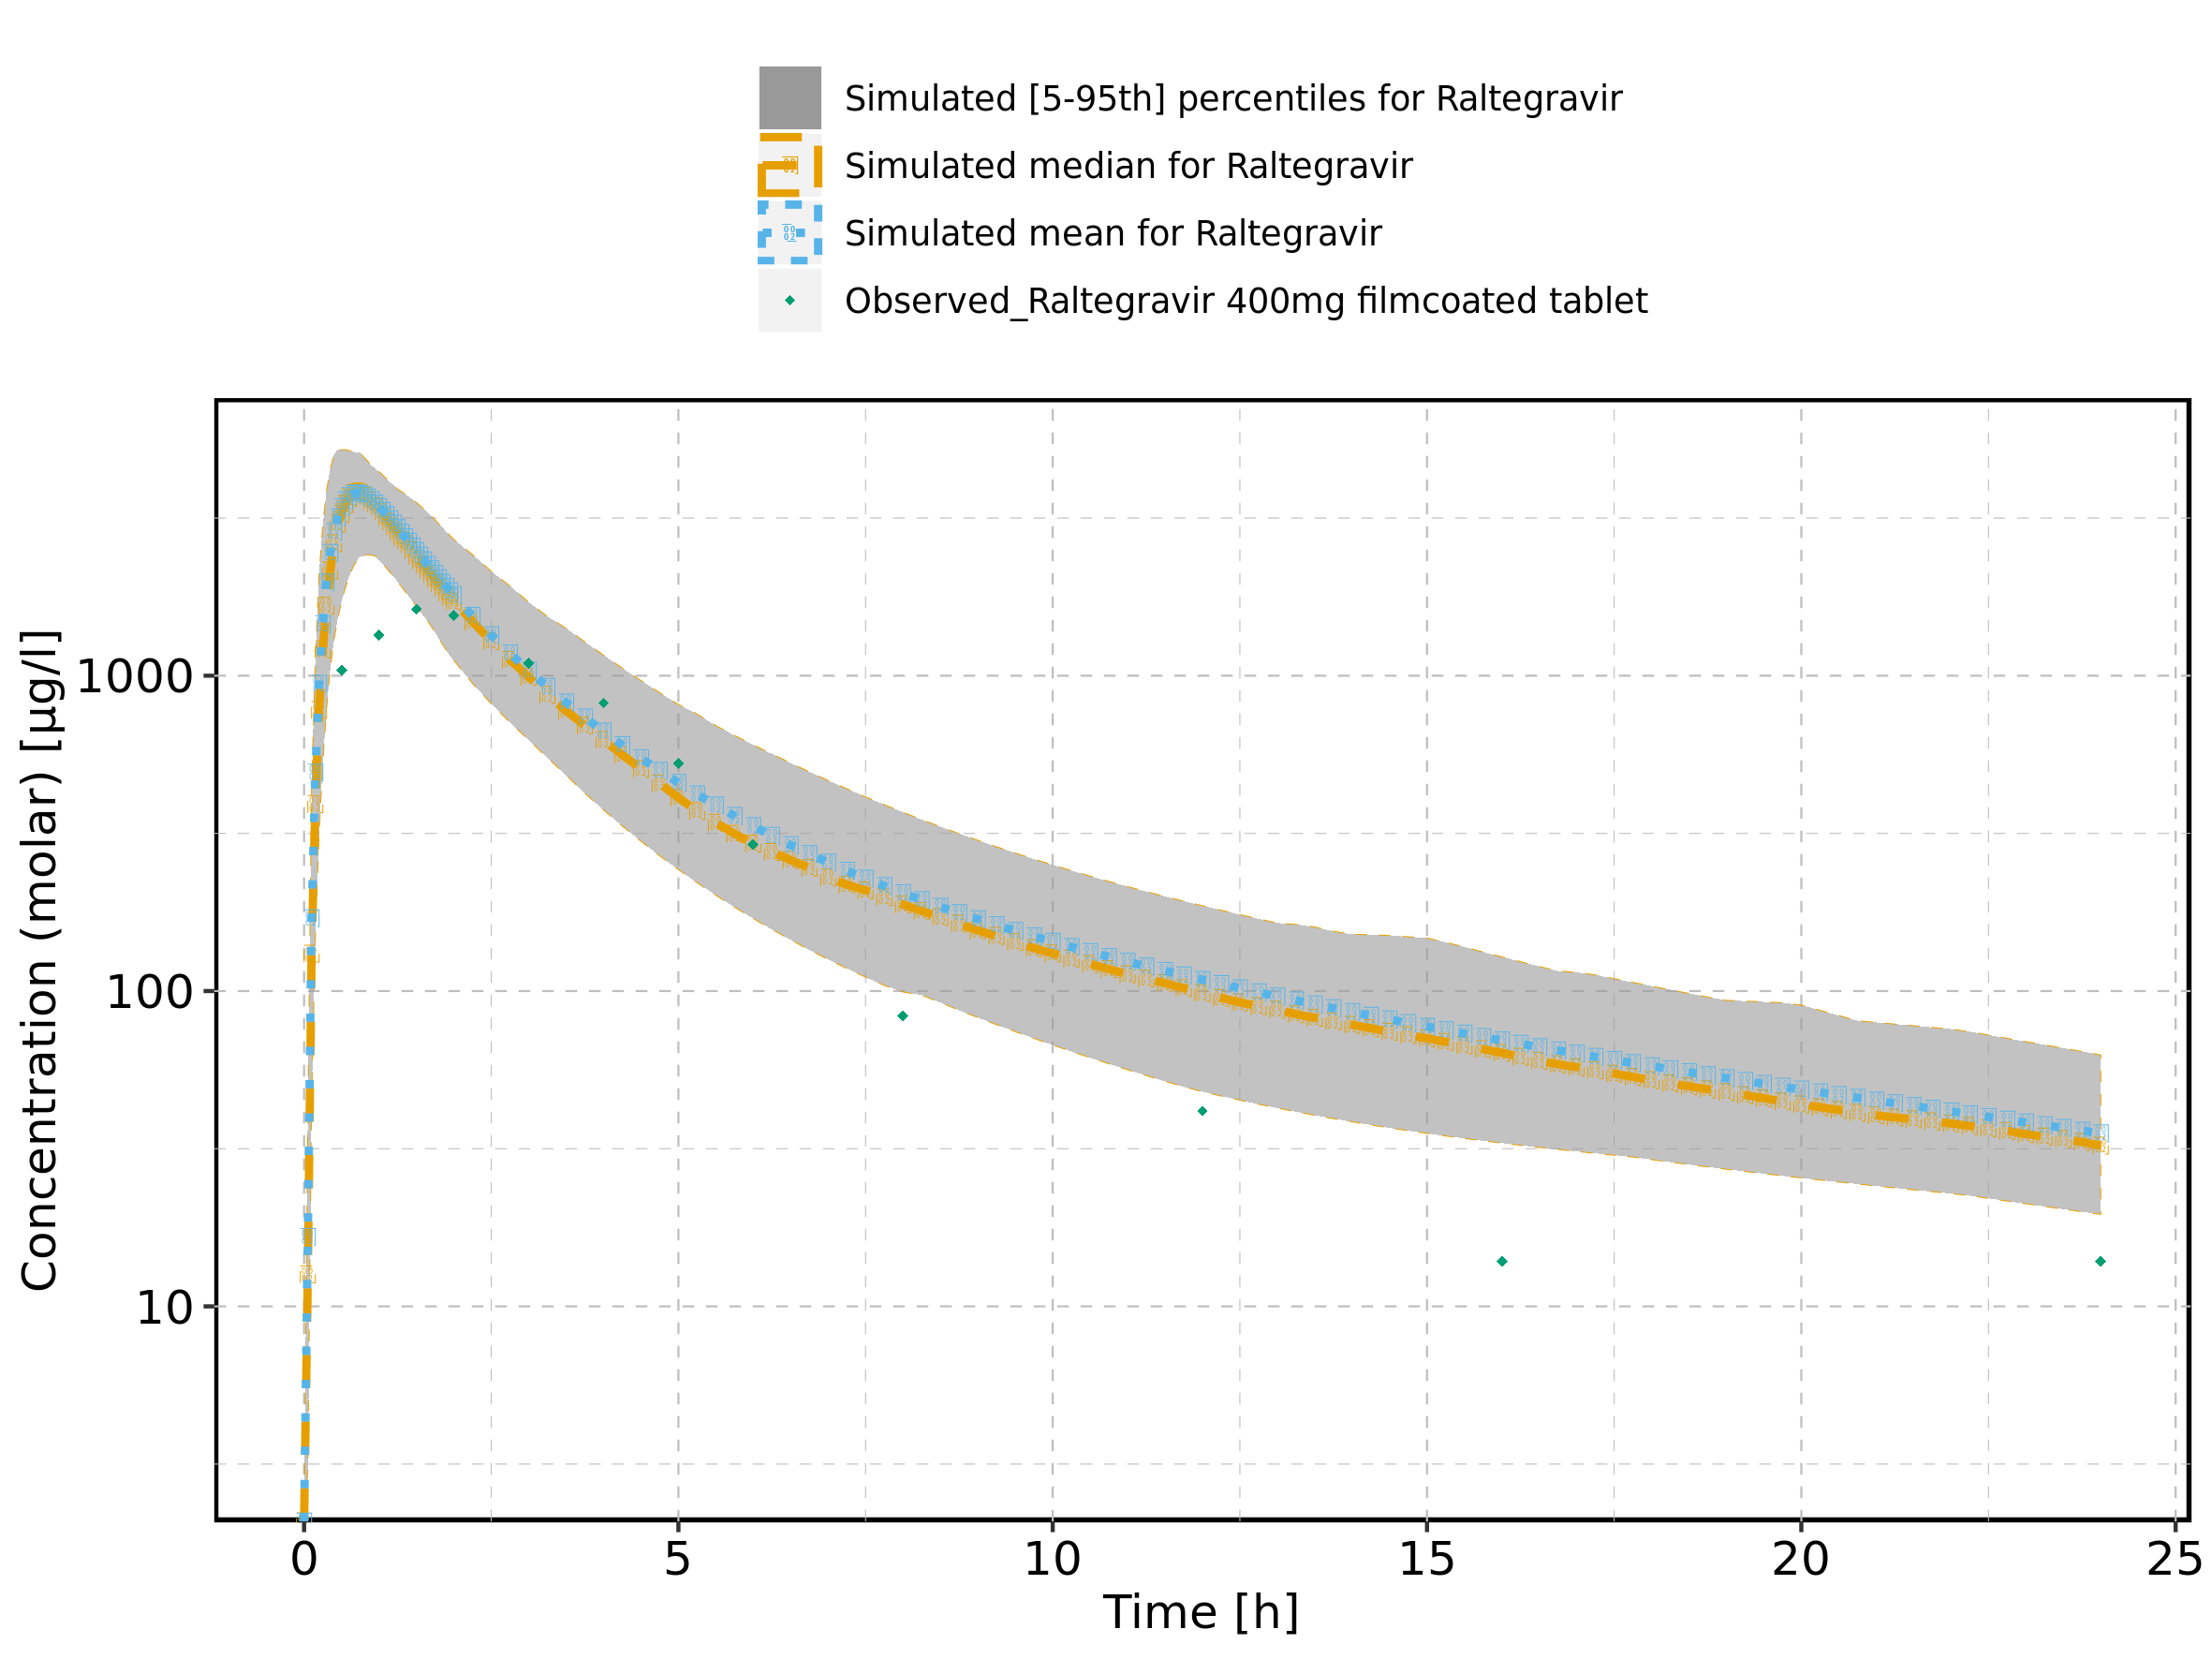

Figure 11: Predicted vs observed of Filmcoated_tablet_400mg_sd for Raltegravir 400mg filmcoated tablet. Data source: Data/Raltegravir_PK.txt. Predictions and observations are plotted in a linear scale.

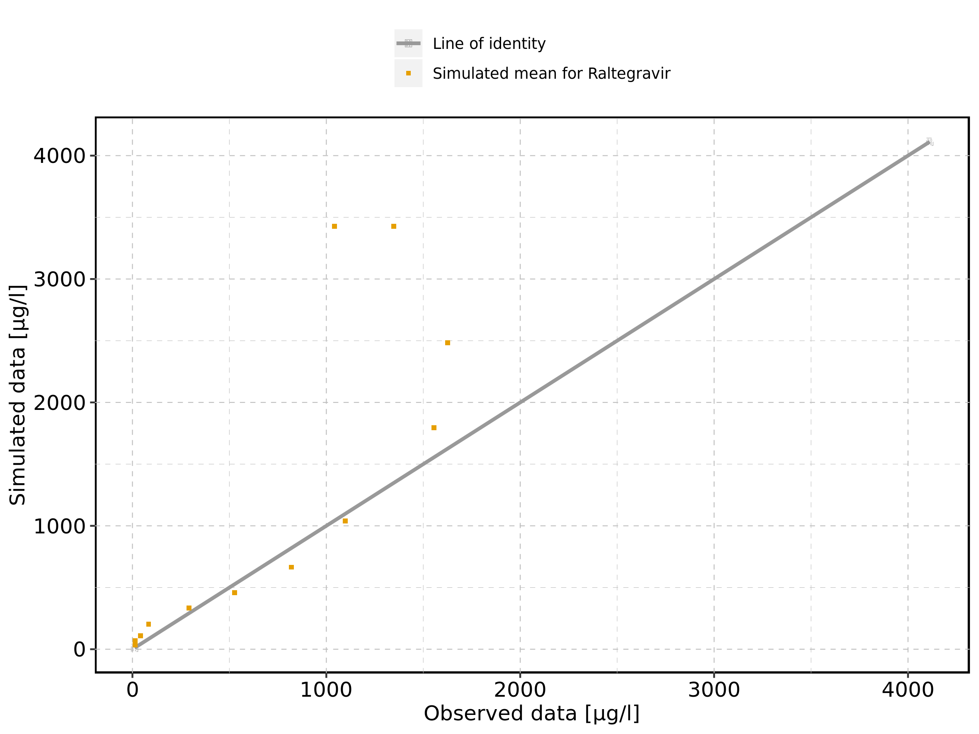

Figure 12: Predicted vs observed of Filmcoated_tablet_400mg_sd for Raltegravir 400mg filmcoated tablet. Data source: Data/Raltegravir_PK.txt. Predictions and observations are plotted in a logarithmic scale.

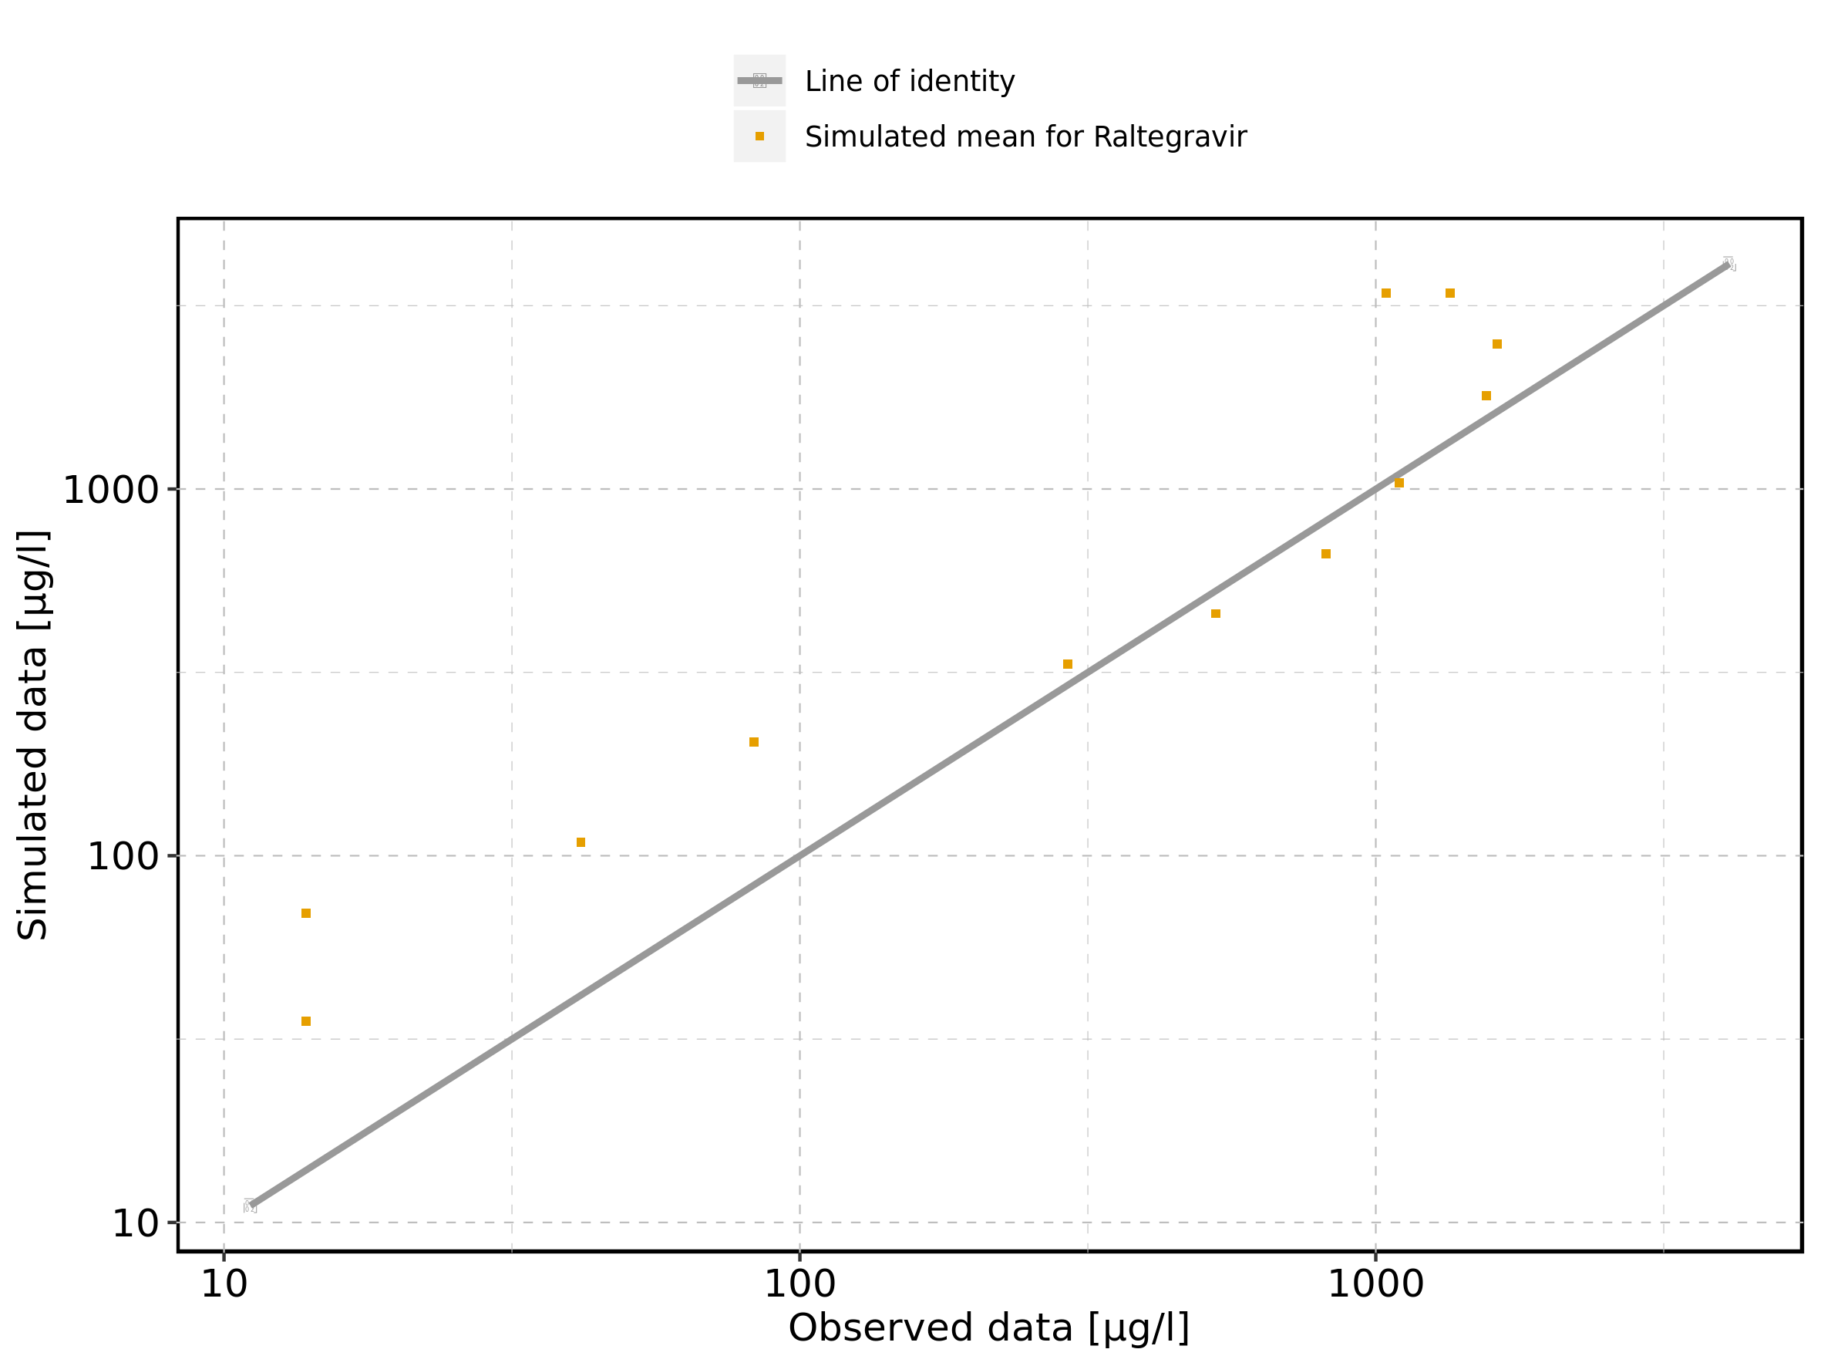

Figure 13: Logarithmic residuals vs predicted values of Filmcoated_tablet_400mg_sd for Raltegravir 400mg filmcoated tablet. Data source: Data/Raltegravir_PK.txt.

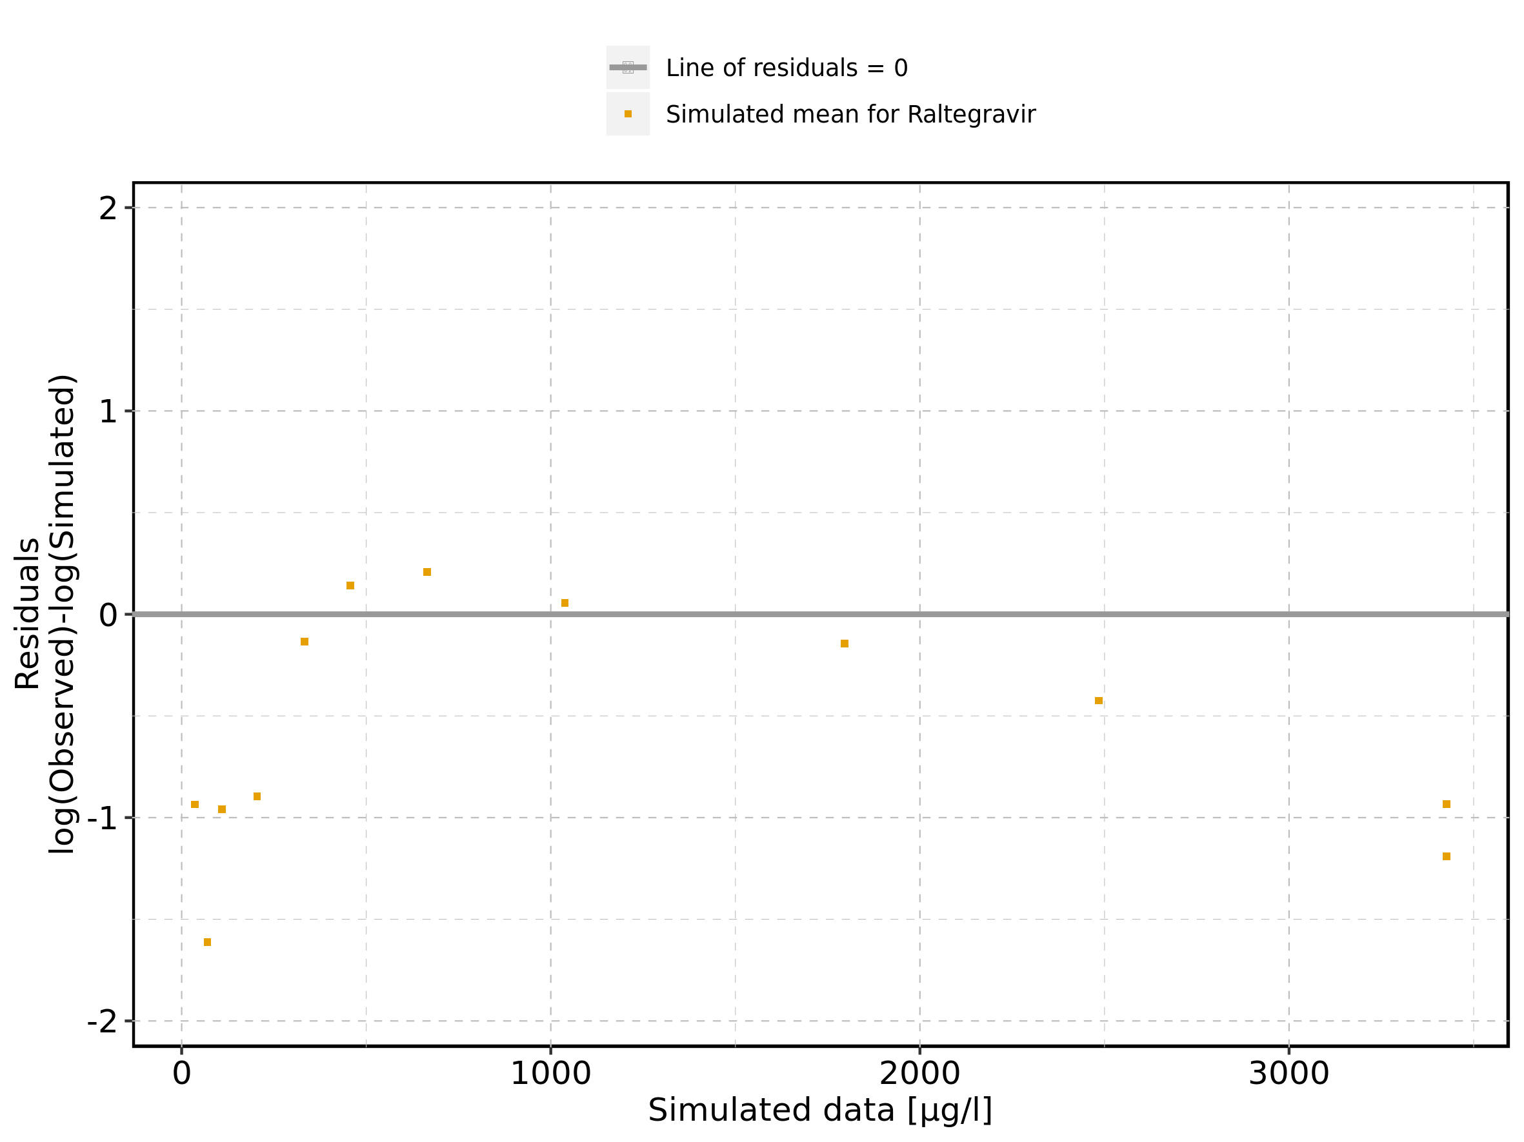

Figure 14: Logarithmic residuals vs time of Filmcoated_tablet_400mg_sd for Raltegravir 400mg filmcoated tablet. Data source: Data/Raltegravir_PK.txt.

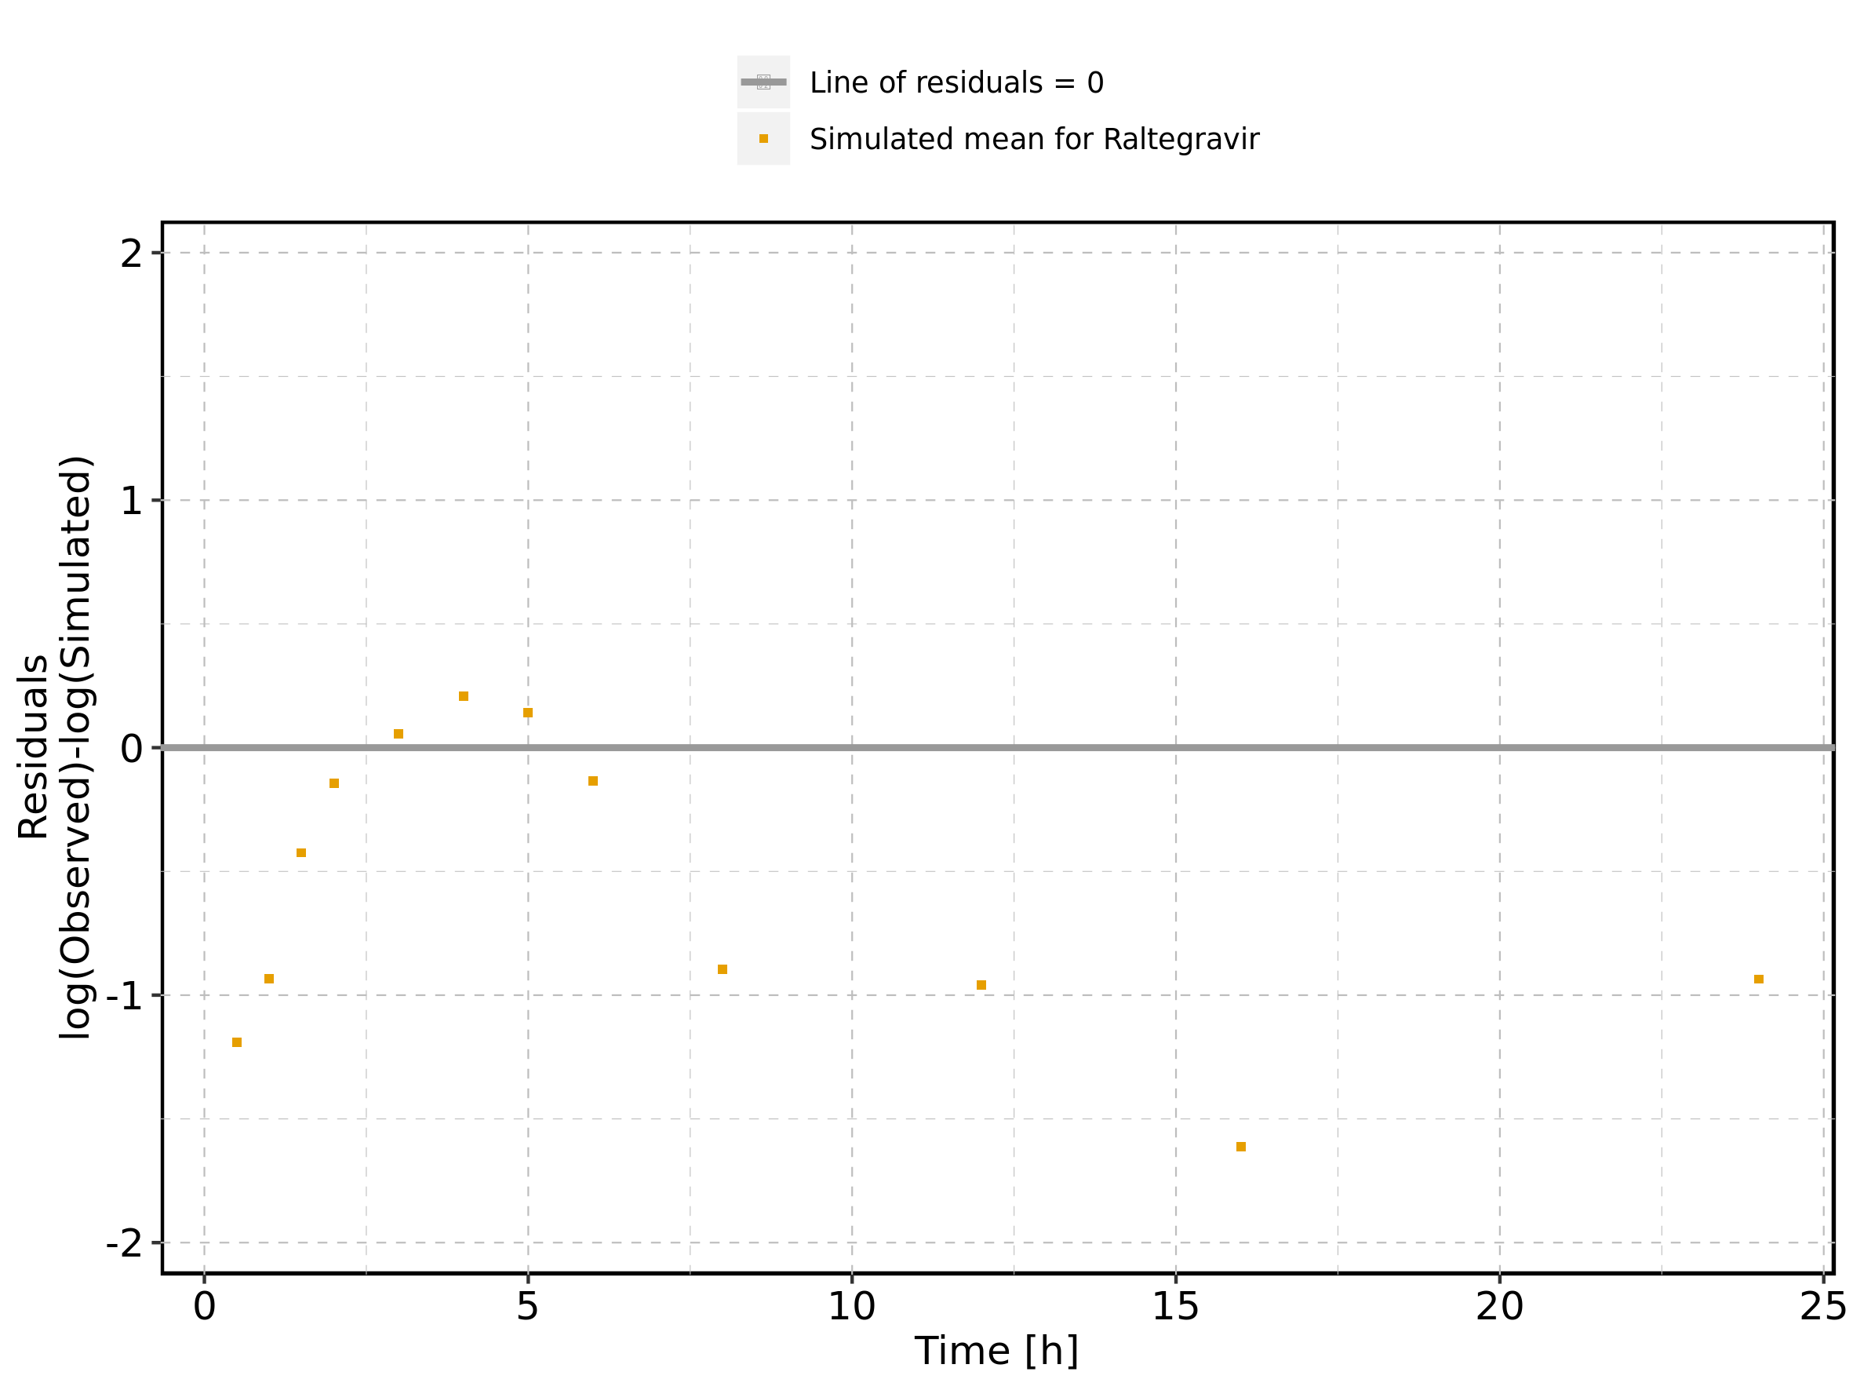

Figure 15: Logarithmic residuals distribution of Filmcoated_tablet_400mg_sd for Raltegravir 400mg filmcoated tablet. Data source: Data/Raltegravir_PK.txt.

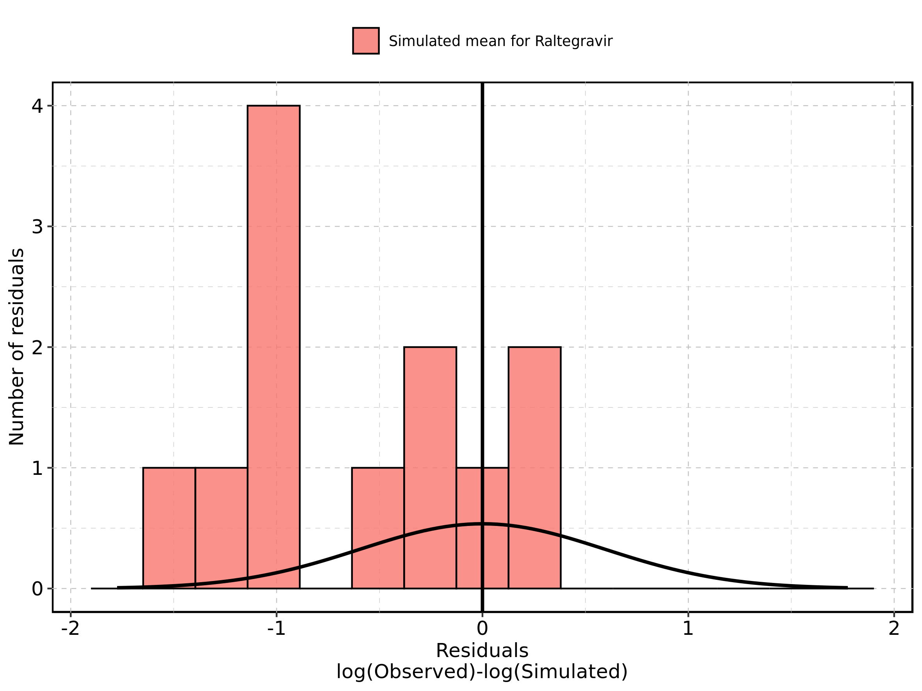

Figure 16: Logarithmic residuals of Filmcoated_tablet_400mg_sd for Raltegravir 400mg filmcoated tablet as quantile-quantile plot. Data source: Data/Raltegravir_PK.txt.

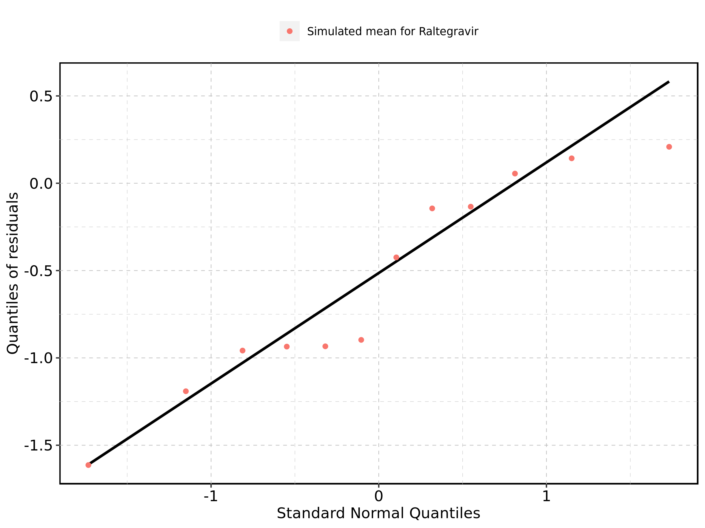

## 2.3. Residuals across all simulations

Figure 17: Distribution of residuals for Larson 2013 8y-18y 400mg FCT meal, Filmcoated_tablet_400mg_sd

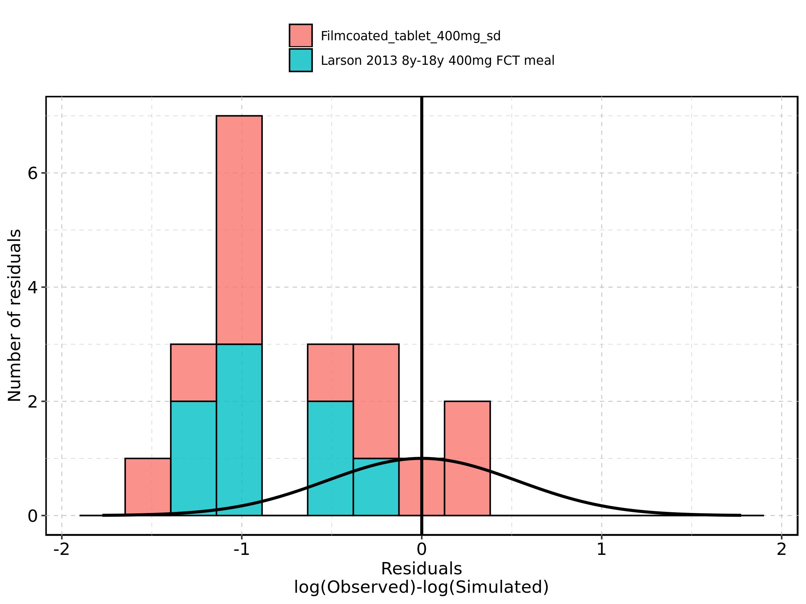

Figure 18: Residuals for Larson 2013 8y-18y 400mg FCT meal, Filmcoated_tablet_400mg_sd as quantile-quantile plot.

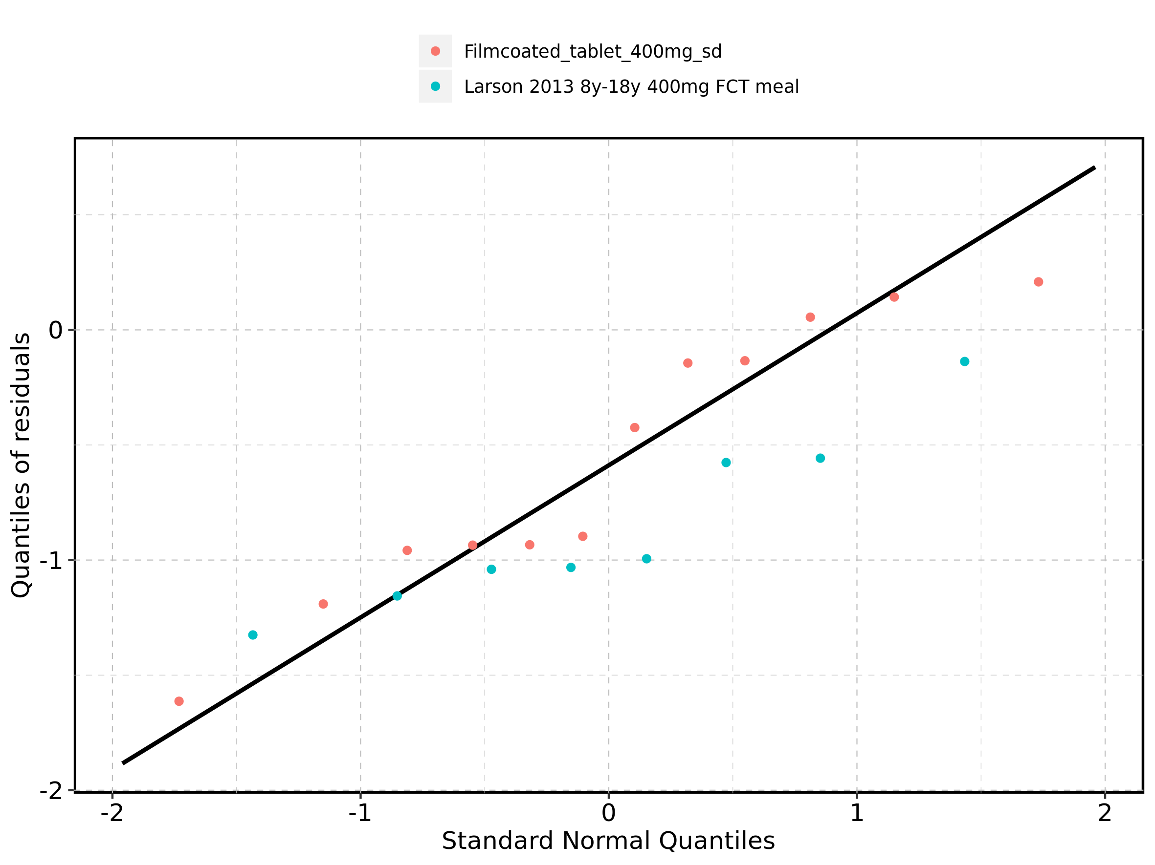

# 3. Demography

Figure 19: Age-dependence of Height for Larson 2013 8y-18y 400mg FCT meal in comparison to Filmcoated_tablet_400mg_sd. Profiles are plotted in a linear scale.

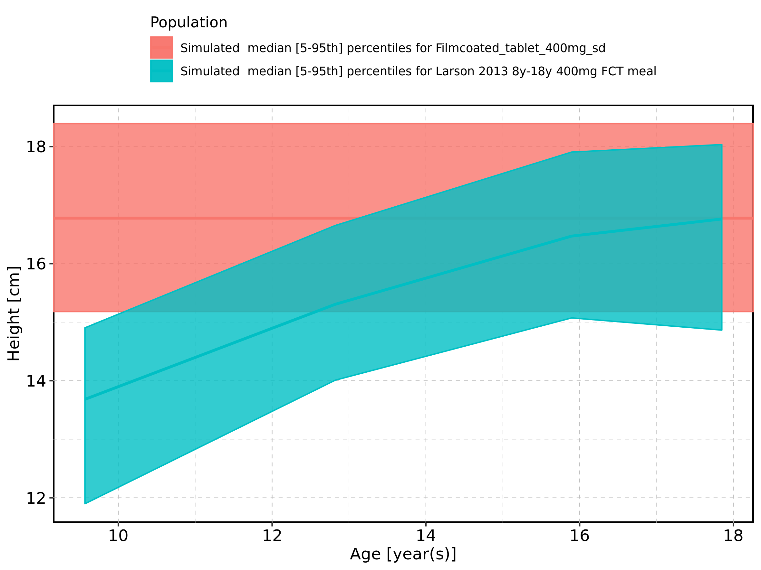

Figure 20: Age-dependence of Height for Larson 2013 8y-18y 400mg FCT meal in comparison to Filmcoated_tablet_400mg_sd. Profiles are plotted in a logarithmic scale.

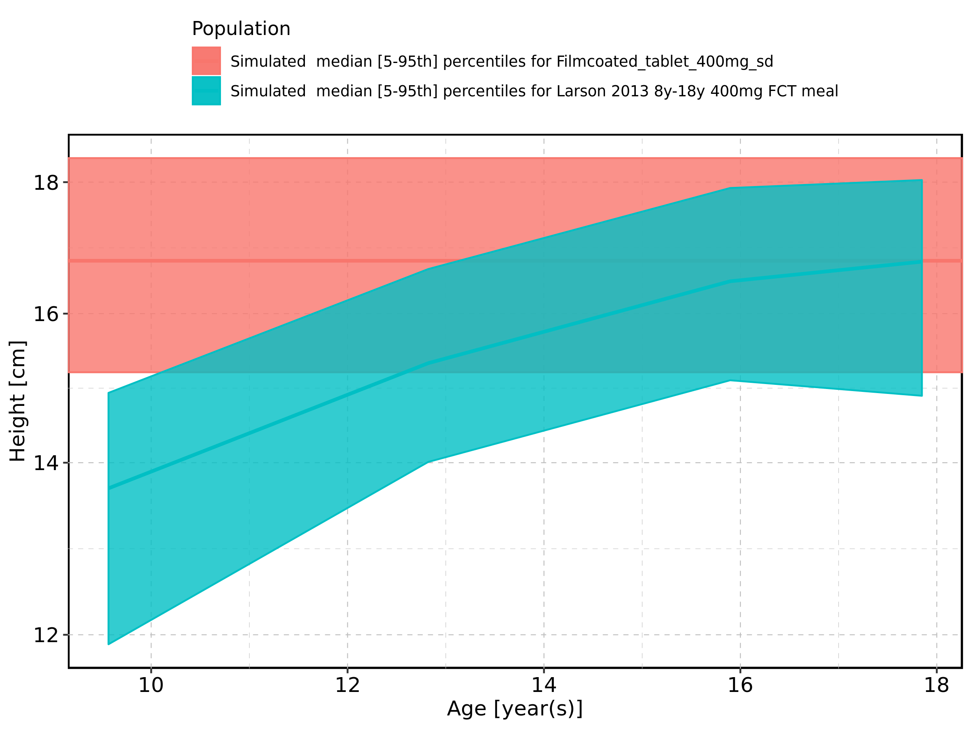

Figure 21: Age-dependence of Height for Larson 2013 8y-18y 400mg FCT meal. Profiles are plotted in a linear scale.

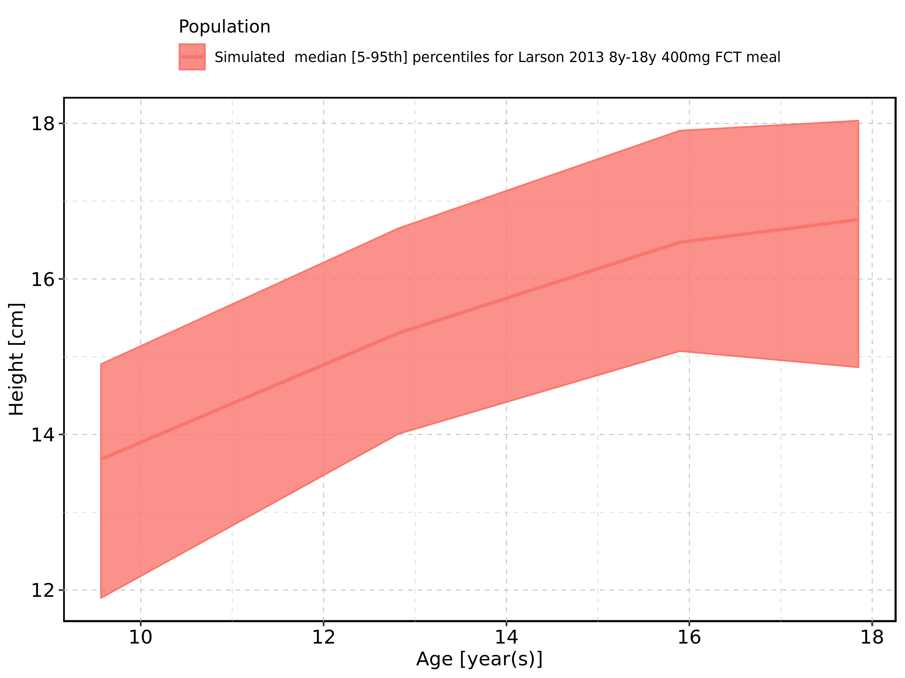

Figure 22: Age-dependence of Height for Larson 2013 8y-18y 400mg FCT meal. Profiles are plotted in a logarithmic scale.

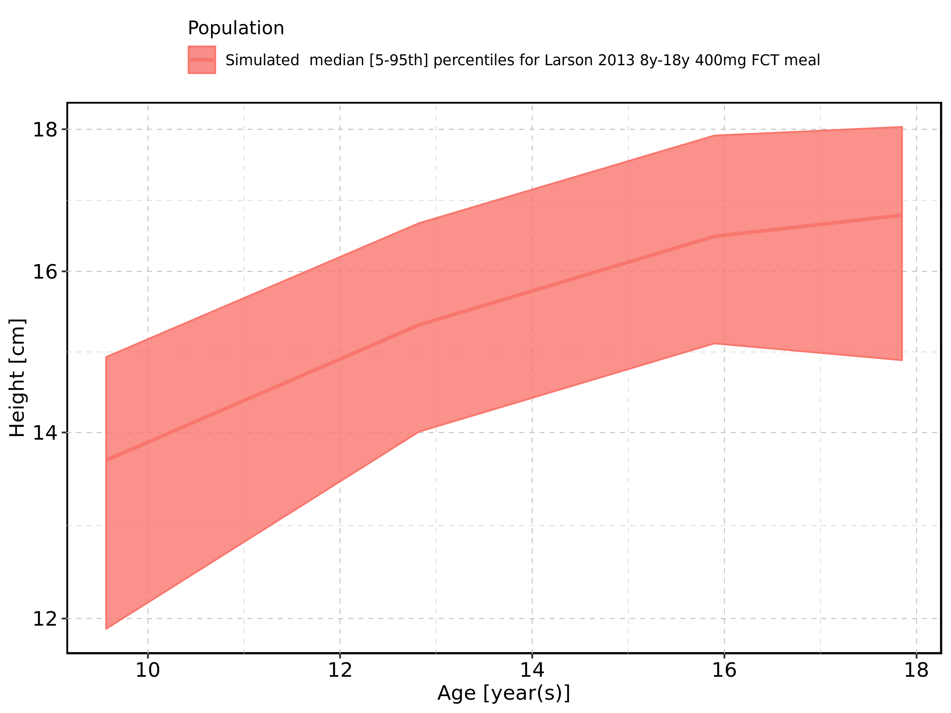

Figure 23: Age-dependence of Height for Filmcoated_tablet_400mg_sd. Profiles are plotted in a linear scale.

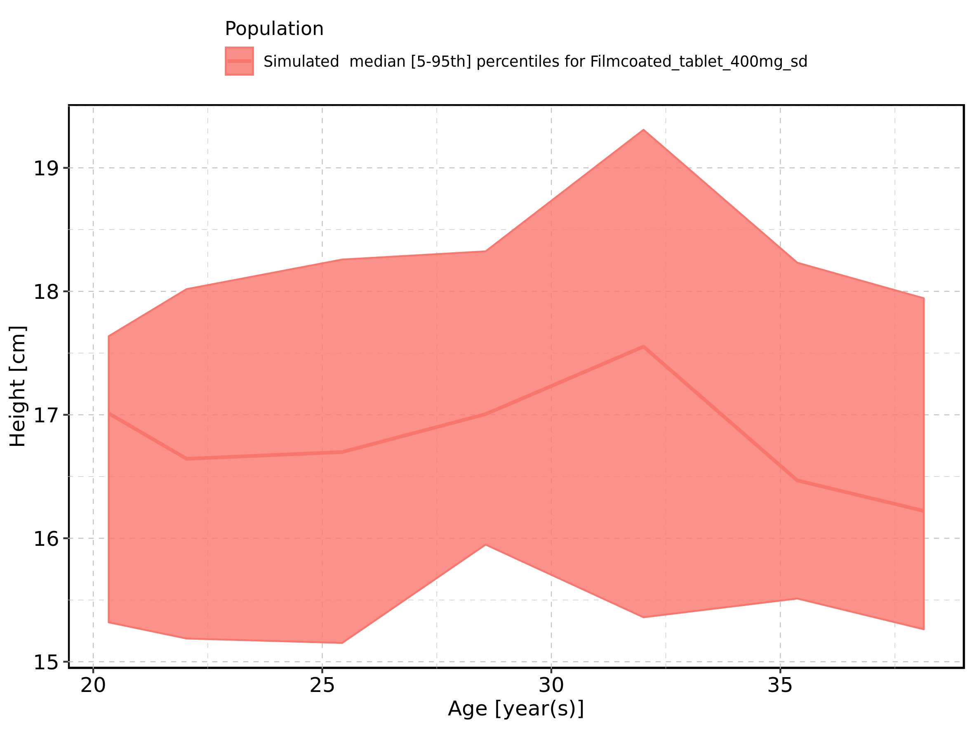

Figure 24: Age-dependence of Height for Filmcoated_tablet_400mg_sd. Profiles are plotted in a logarithmic scale.

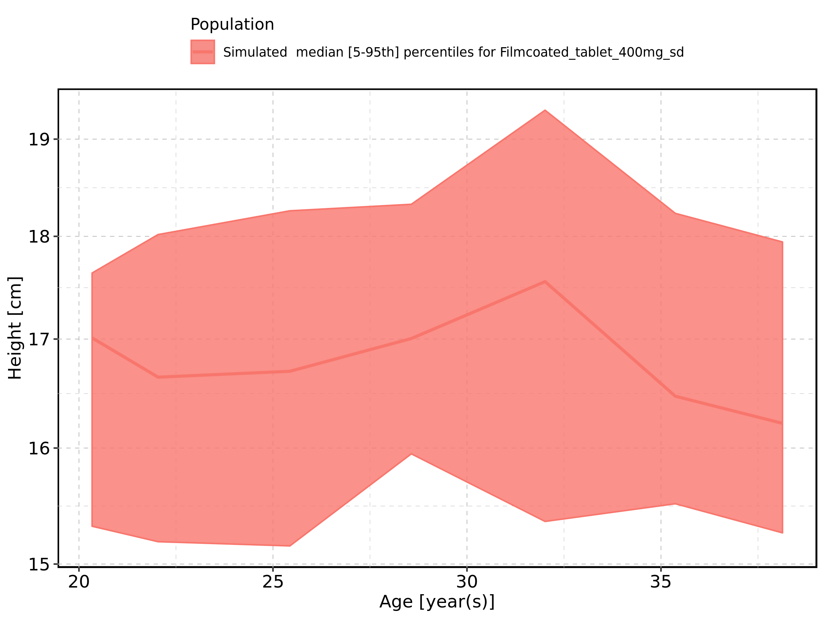

Figure 25: Age-dependence of Weight for Larson 2013 8y-18y 400mg FCT meal in comparison to Filmcoated_tablet_400mg_sd. Profiles are plotted in a linear scale.

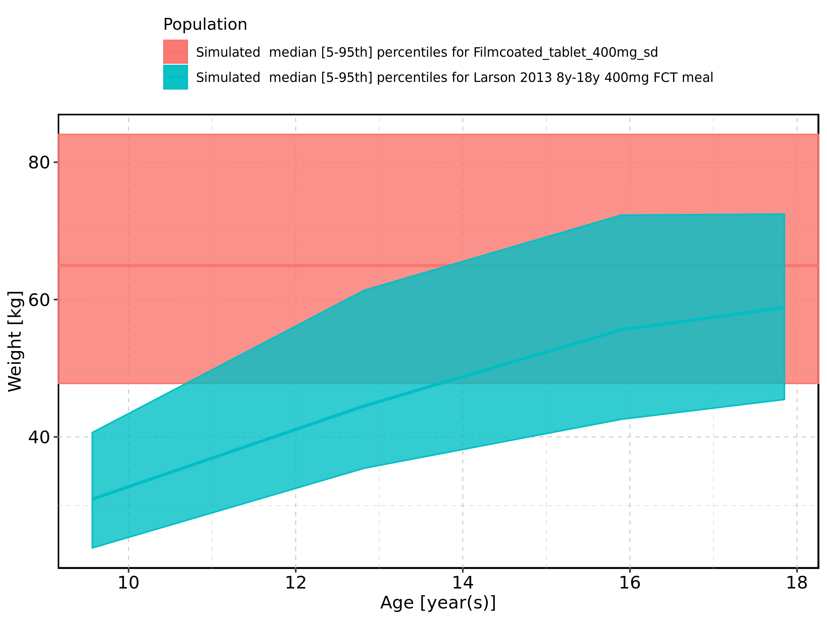

Figure 26: Age-dependence of Weight for Larson 2013 8y-18y 400mg FCT meal in comparison to Filmcoated_tablet_400mg_sd. Profiles are plotted in a logarithmic scale.

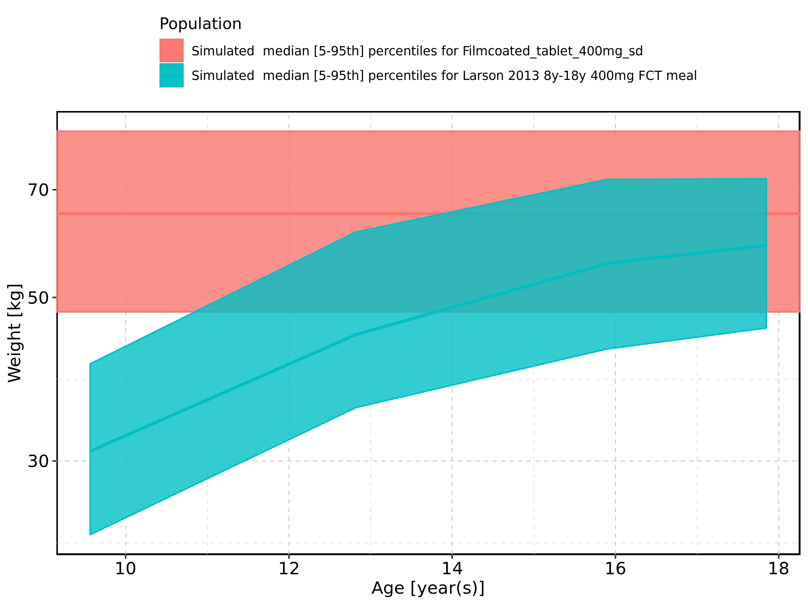

Figure 27: Age-dependence of Weight for Larson 2013 8y-18y 400mg FCT meal. Profiles are plotted in a linear scale.

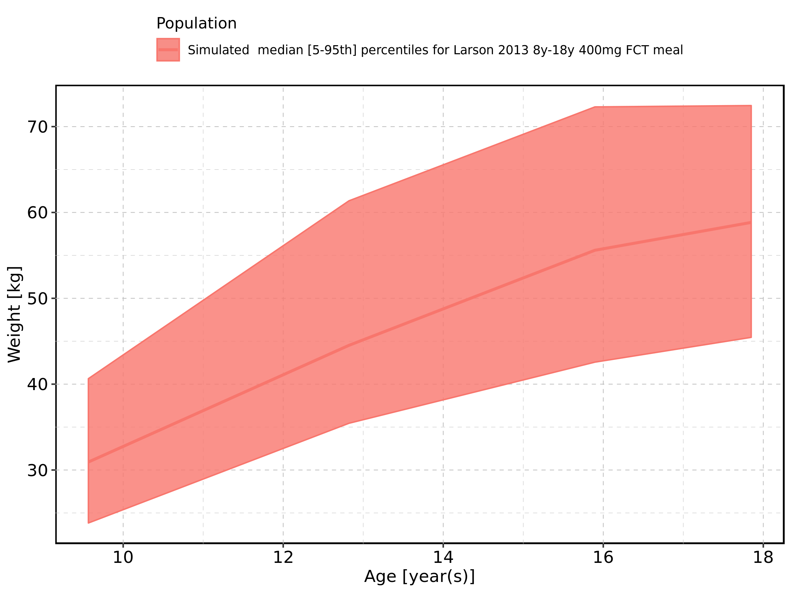

Figure 28: Age-dependence of Weight for Larson 2013 8y-18y 400mg FCT meal. Profiles are plotted in a logarithmic scale.

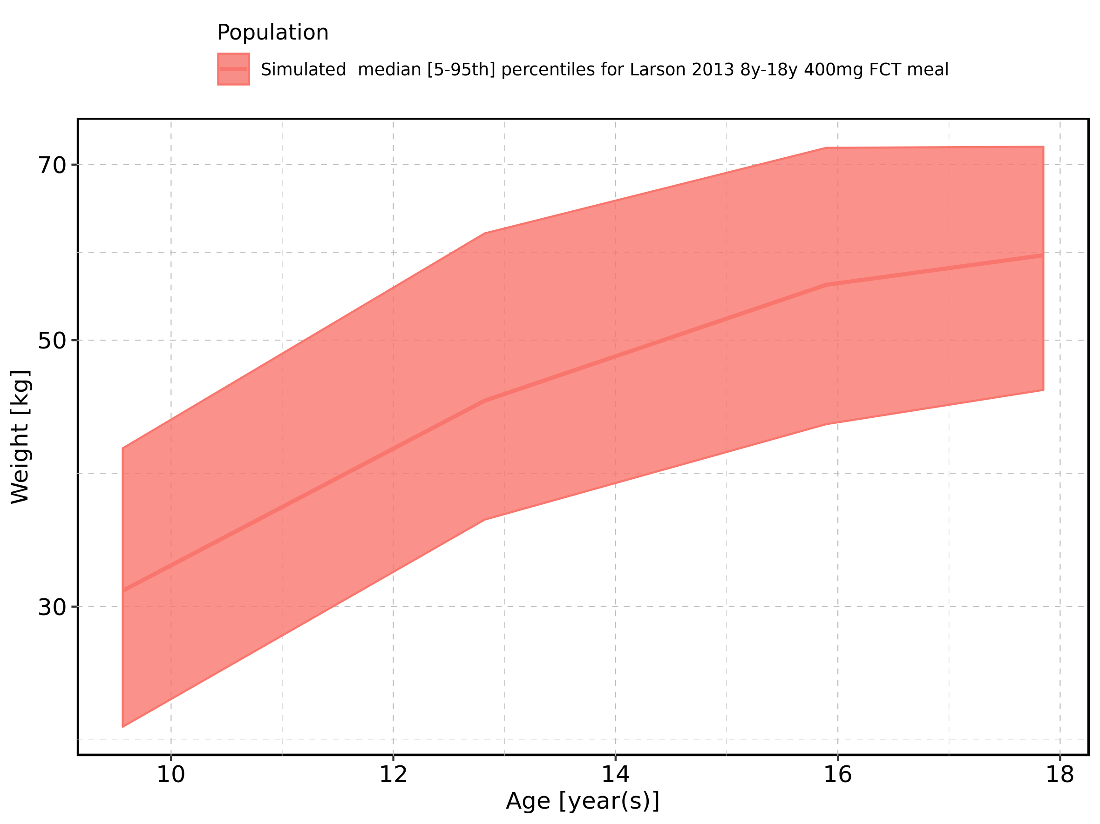

Figure 29: Age-dependence of Weight for Filmcoated_tablet_400mg_sd. Profiles are plotted in a linear scale.

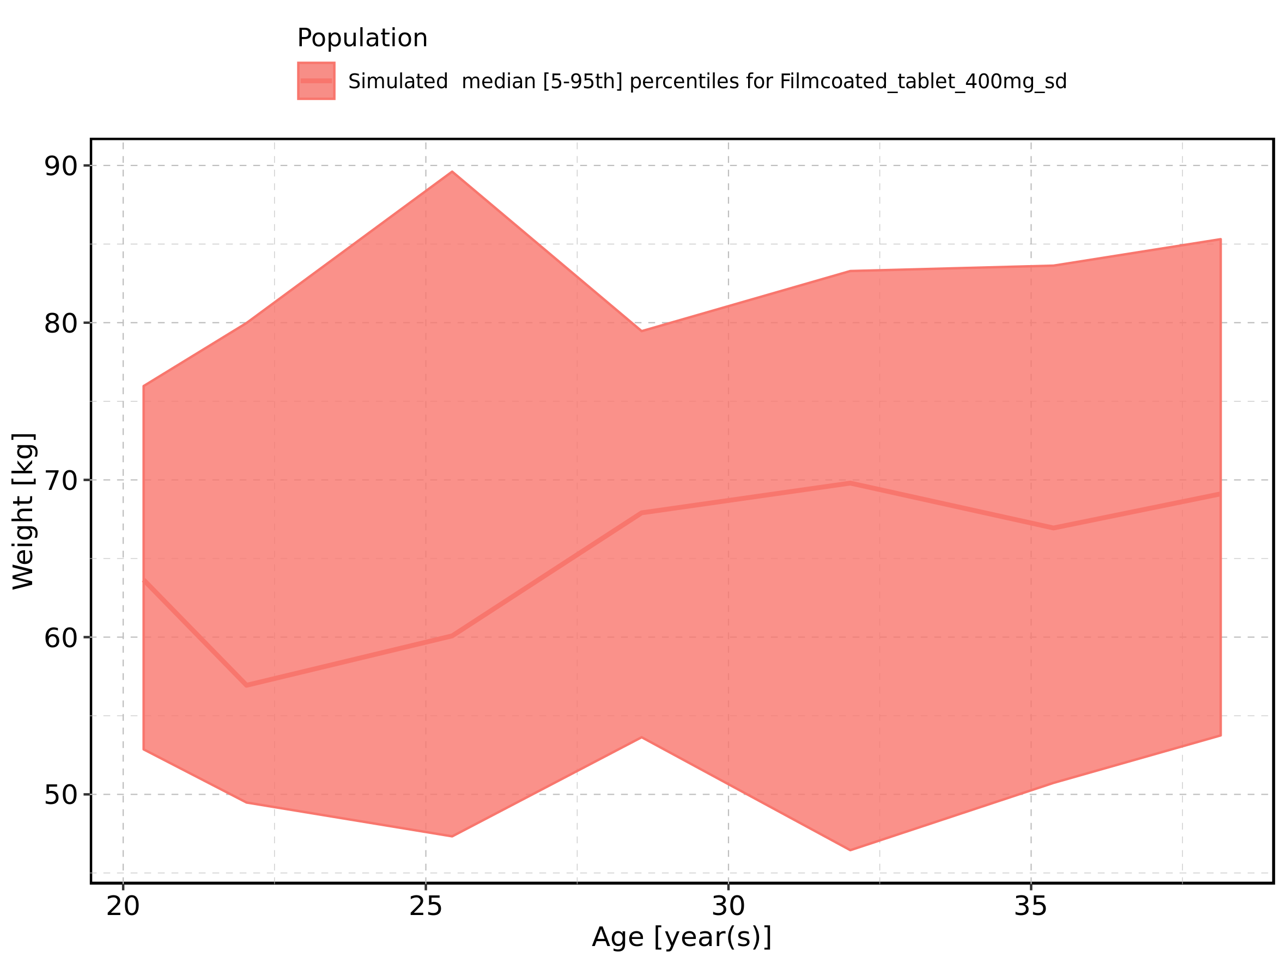

Figure 30: Age-dependence of Weight for Filmcoated_tablet_400mg_sd. Profiles are plotted in a logarithmic scale.

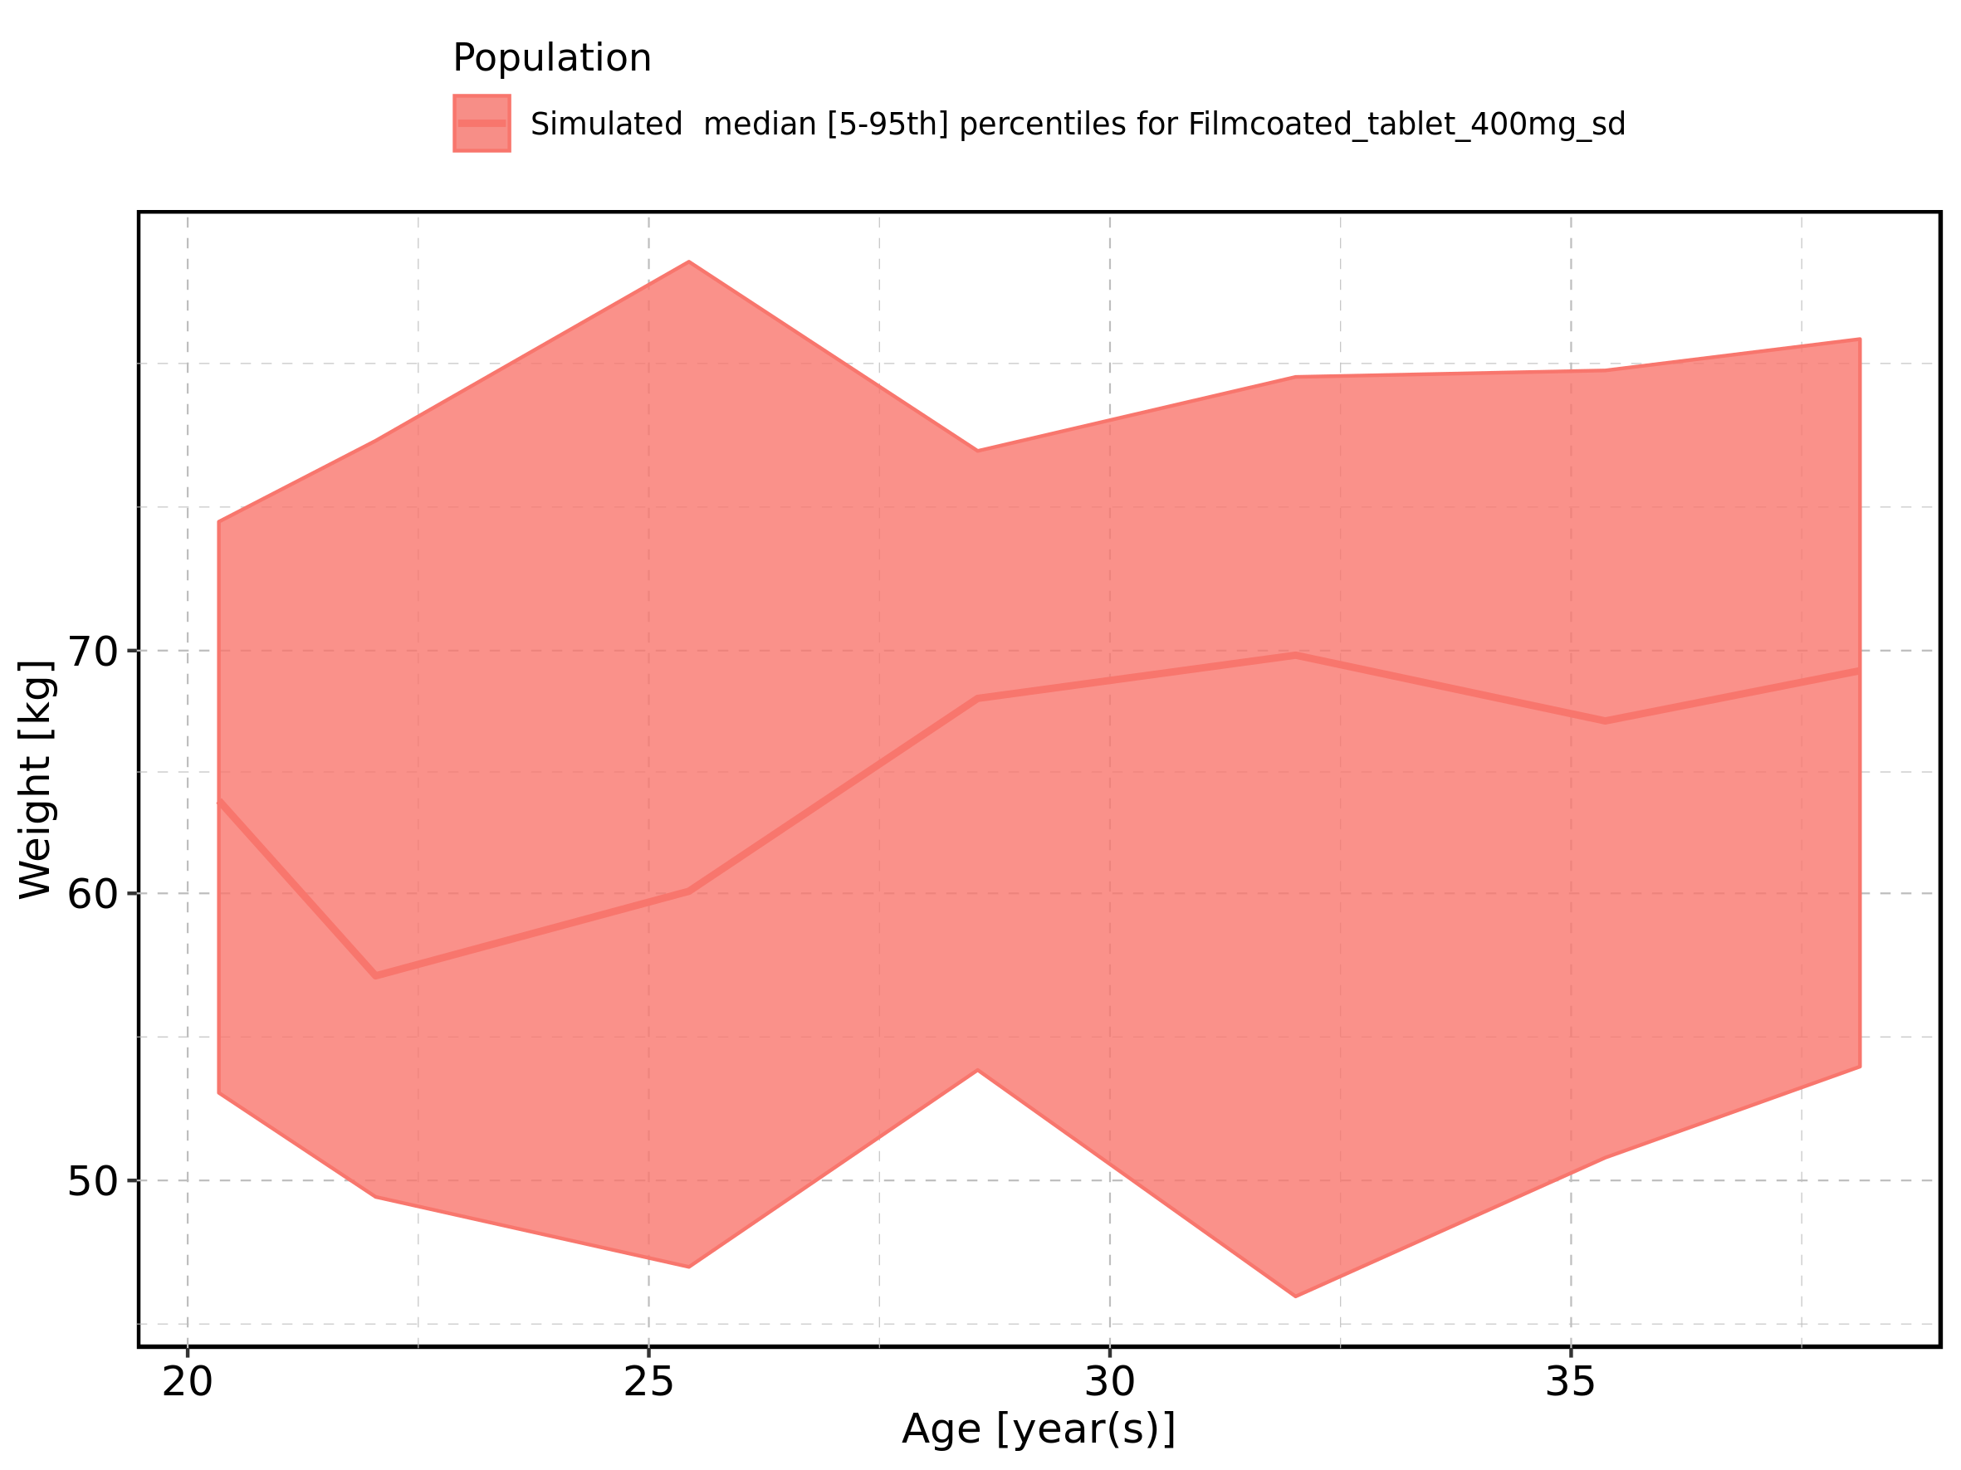

Figure 31: Age-dependence of BMI for Larson 2013 8y-18y 400mg FCT meal in comparison to Filmcoated_tablet_400mg_sd. Profiles are plotted in a linear scale.

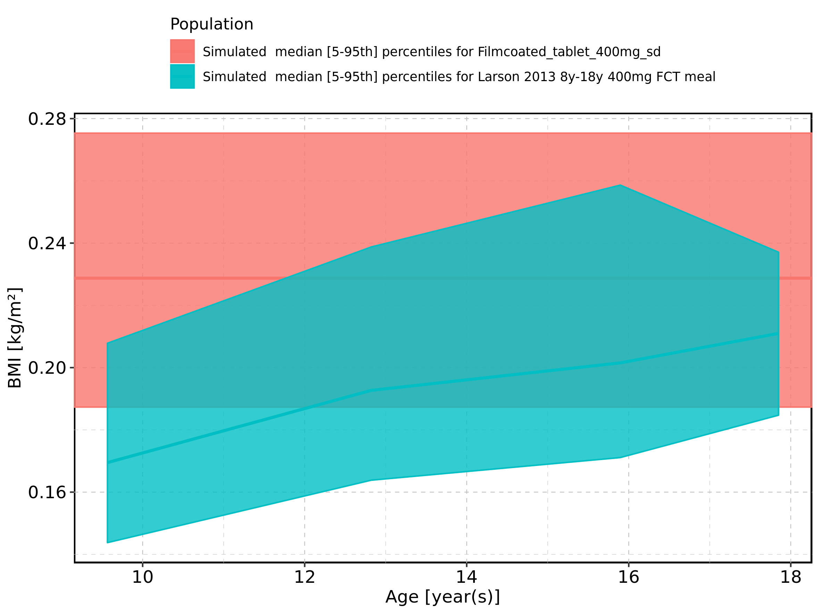

Figure 32: Age-dependence of BMI for Larson 2013 8y-18y 400mg FCT meal in comparison to Filmcoated_tablet_400mg_sd. Profiles are plotted in a logarithmic scale.

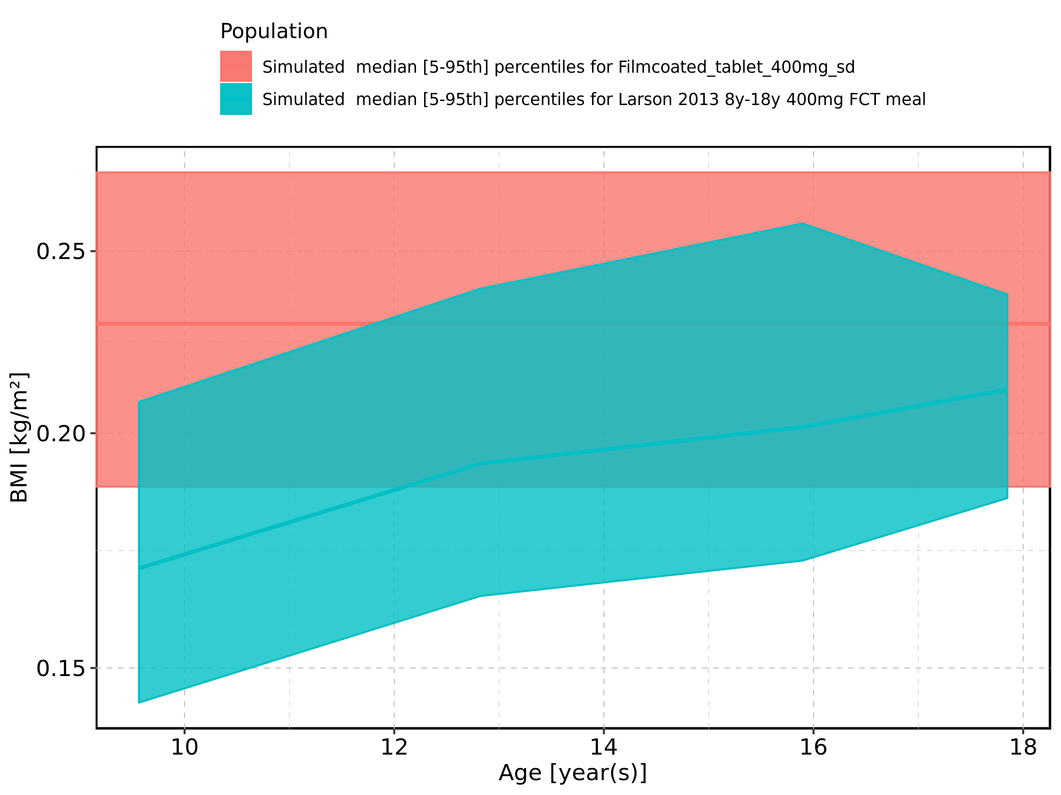

Figure 33: Age-dependence of BMI for Larson 2013 8y-18y 400mg FCT meal. Profiles are plotted in a linear scale.

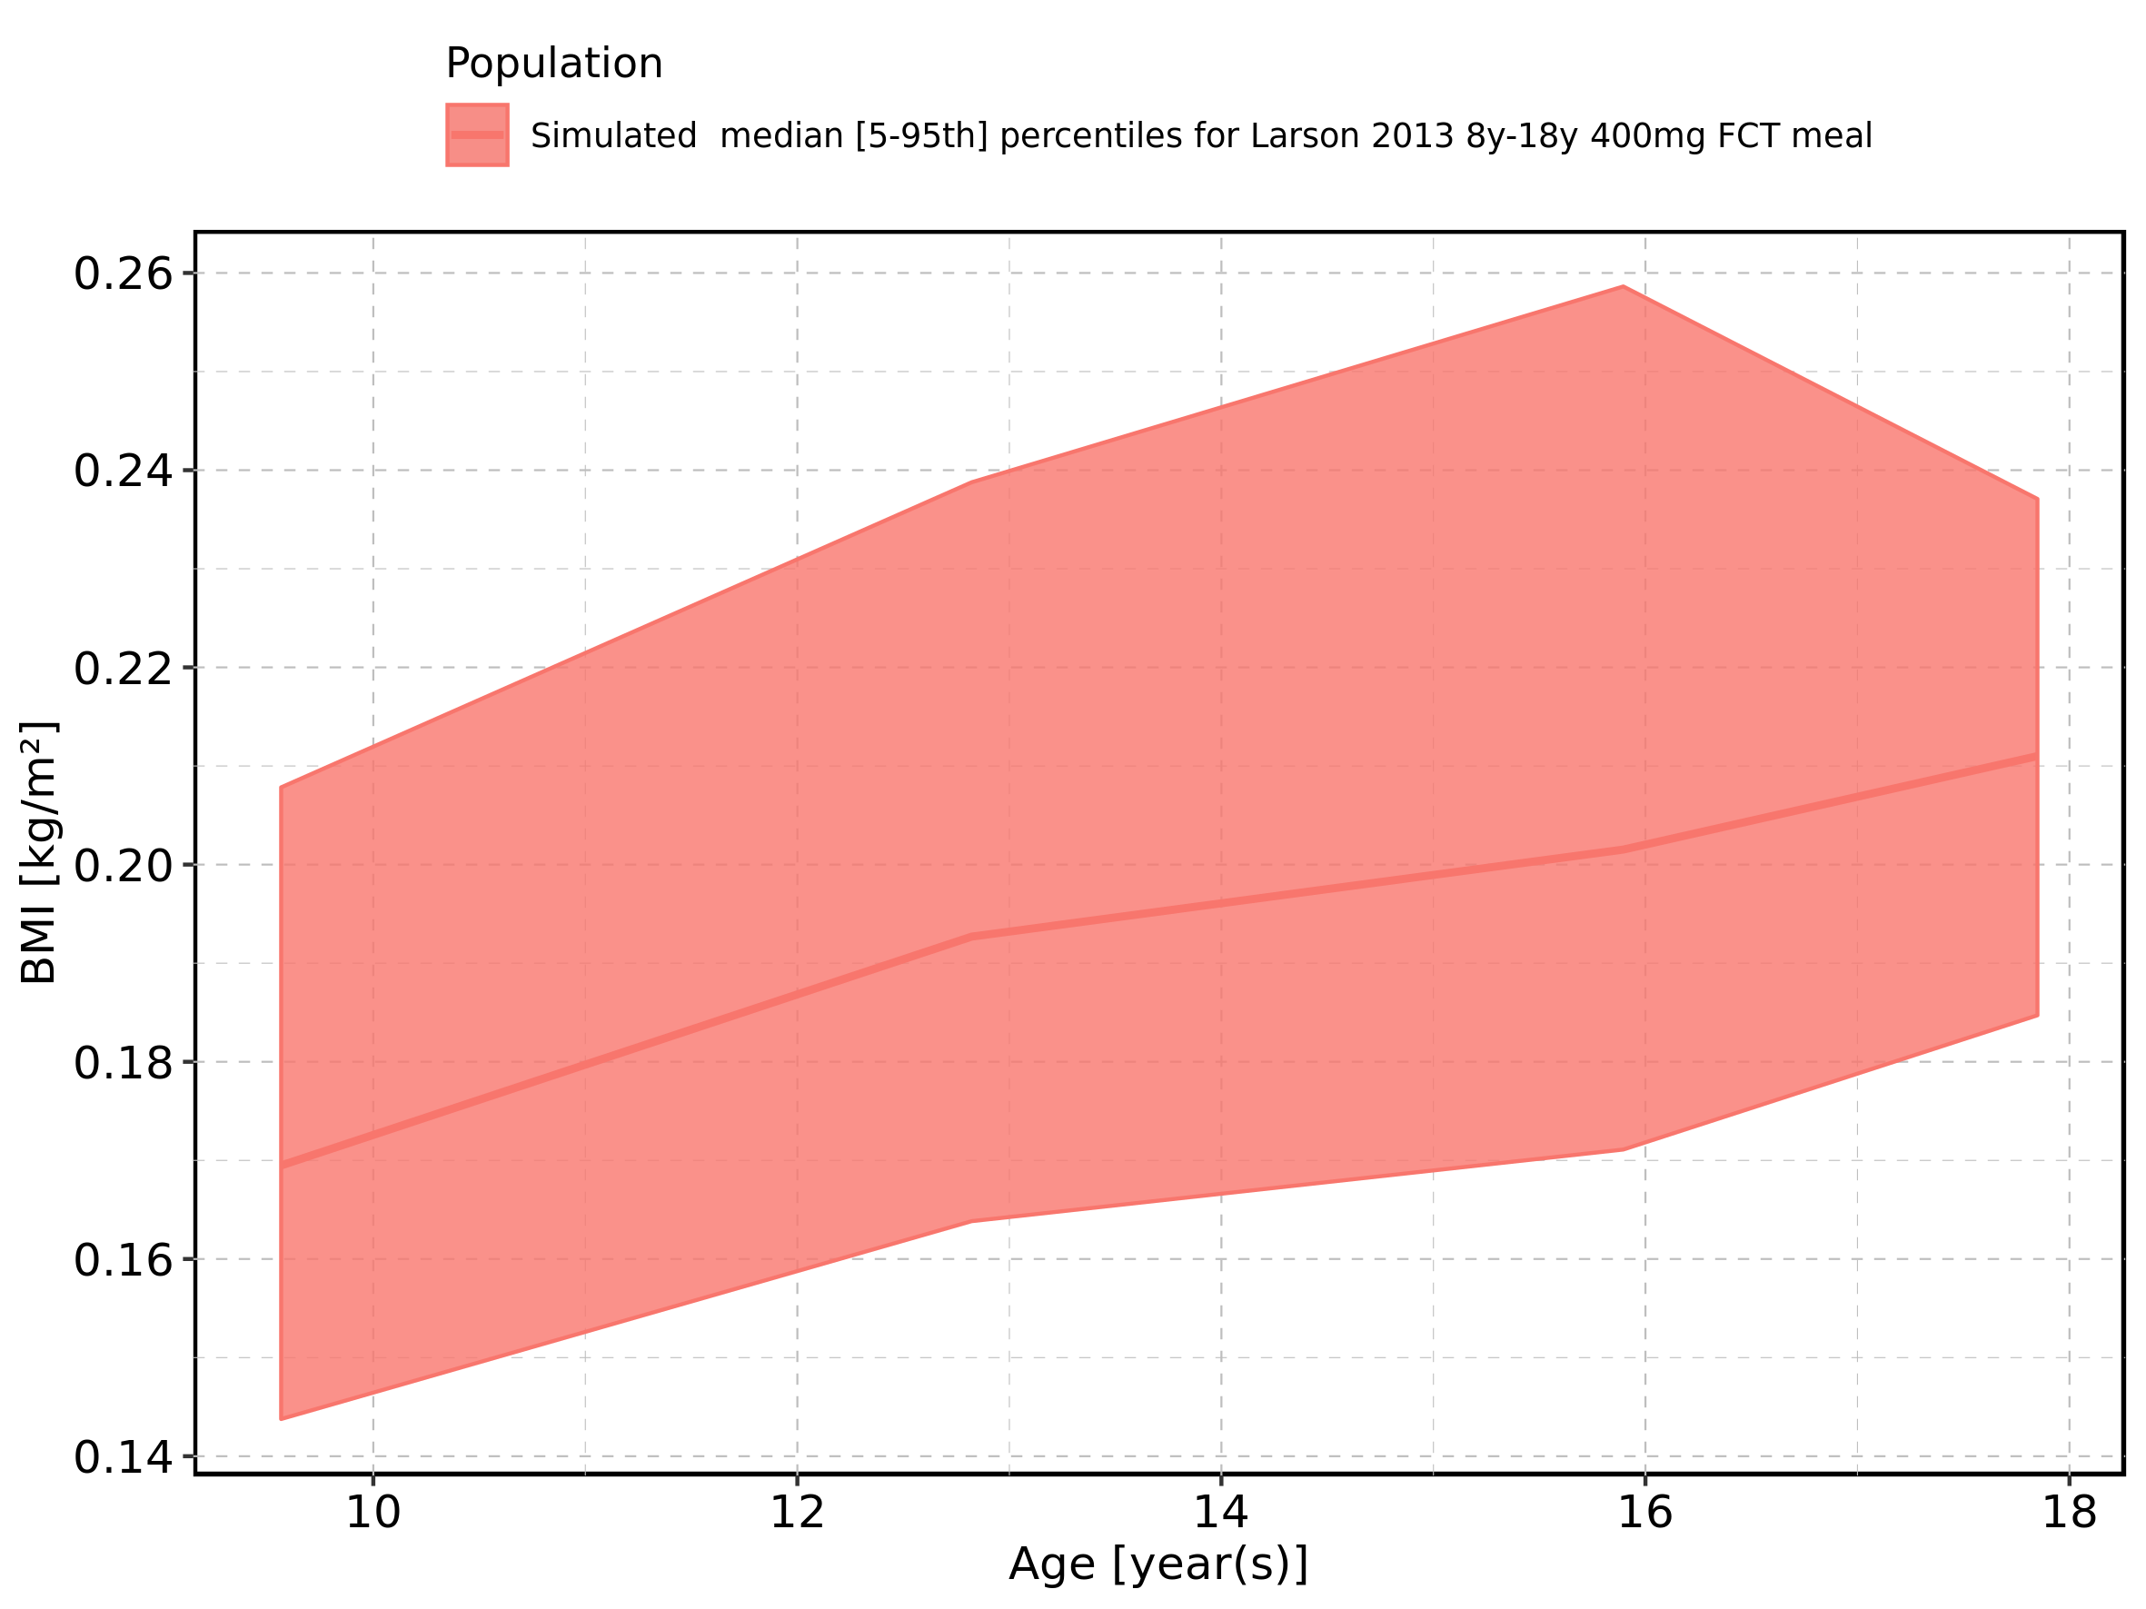

Figure 34: Age-dependence of BMI for Larson 2013 8y-18y 400mg FCT meal. Profiles are plotted in a logarithmic scale.

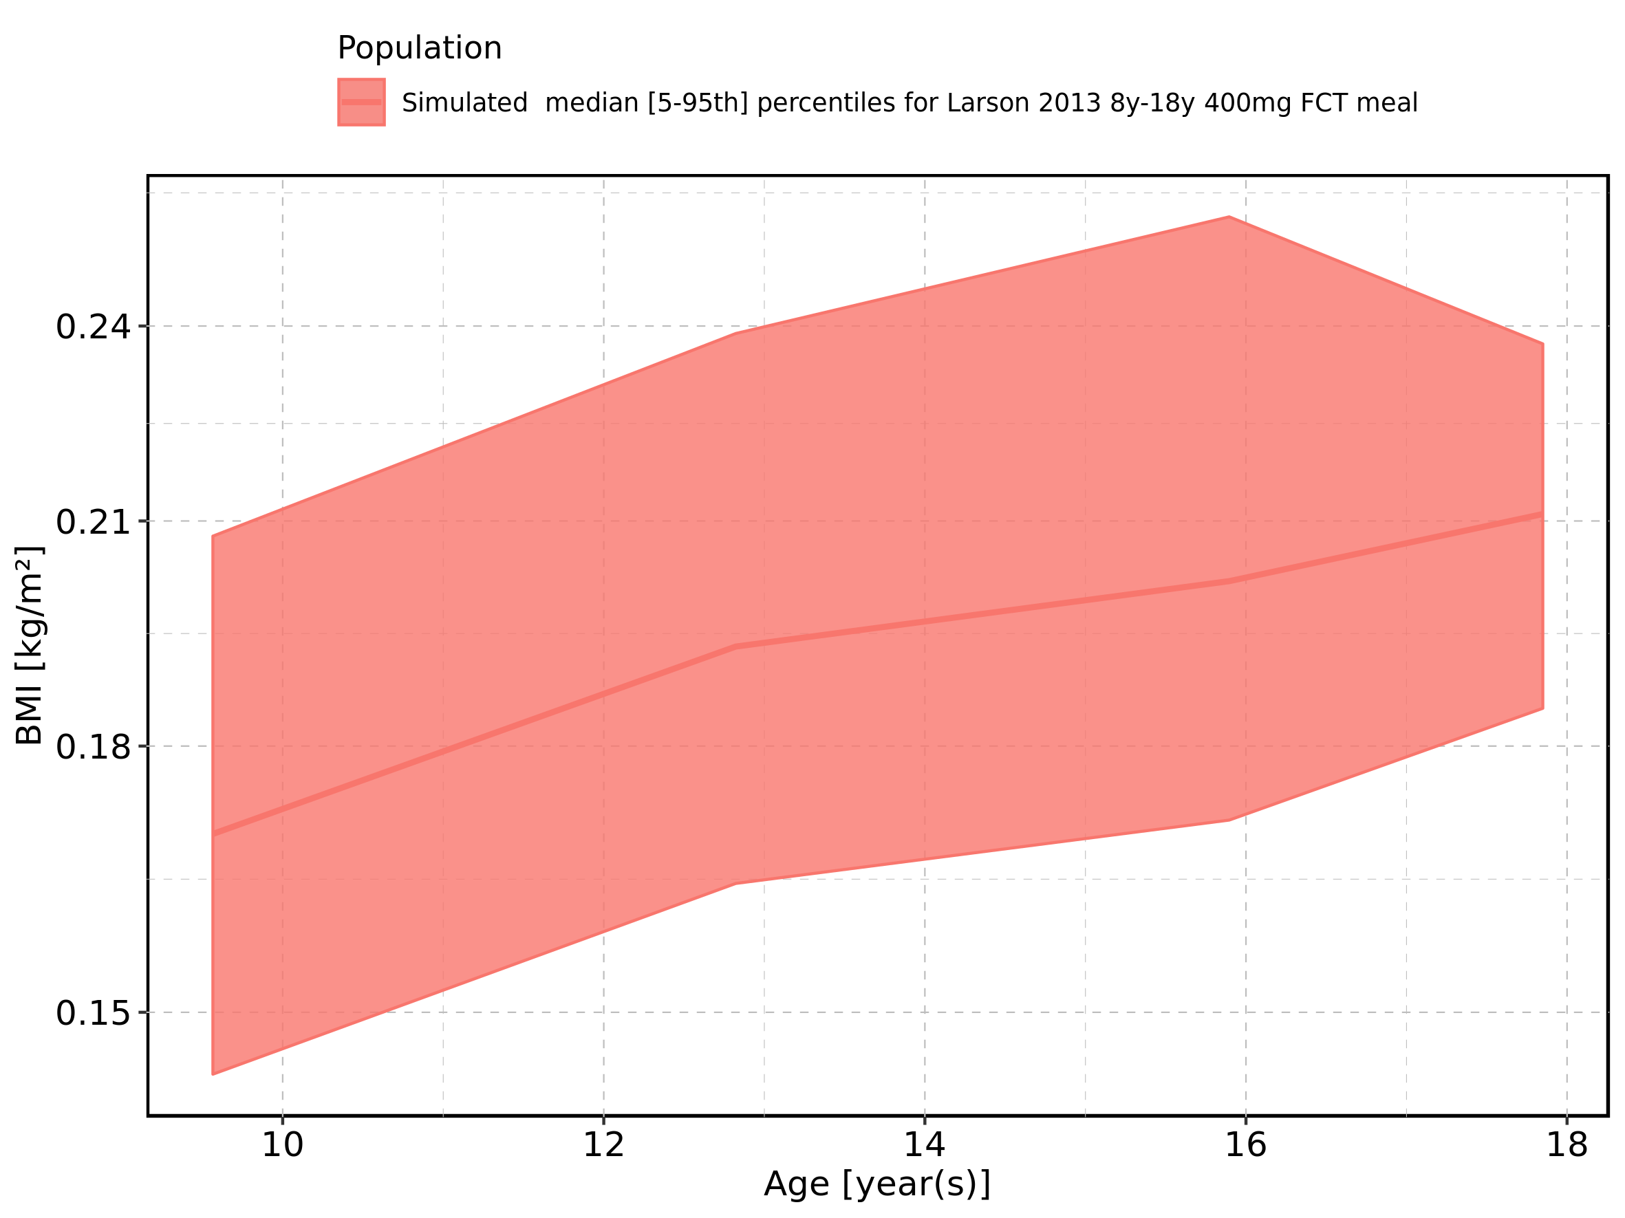

Figure 35: Age-dependence of BMI for Filmcoated_tablet_400mg_sd. Profiles are plotted in a linear scale.

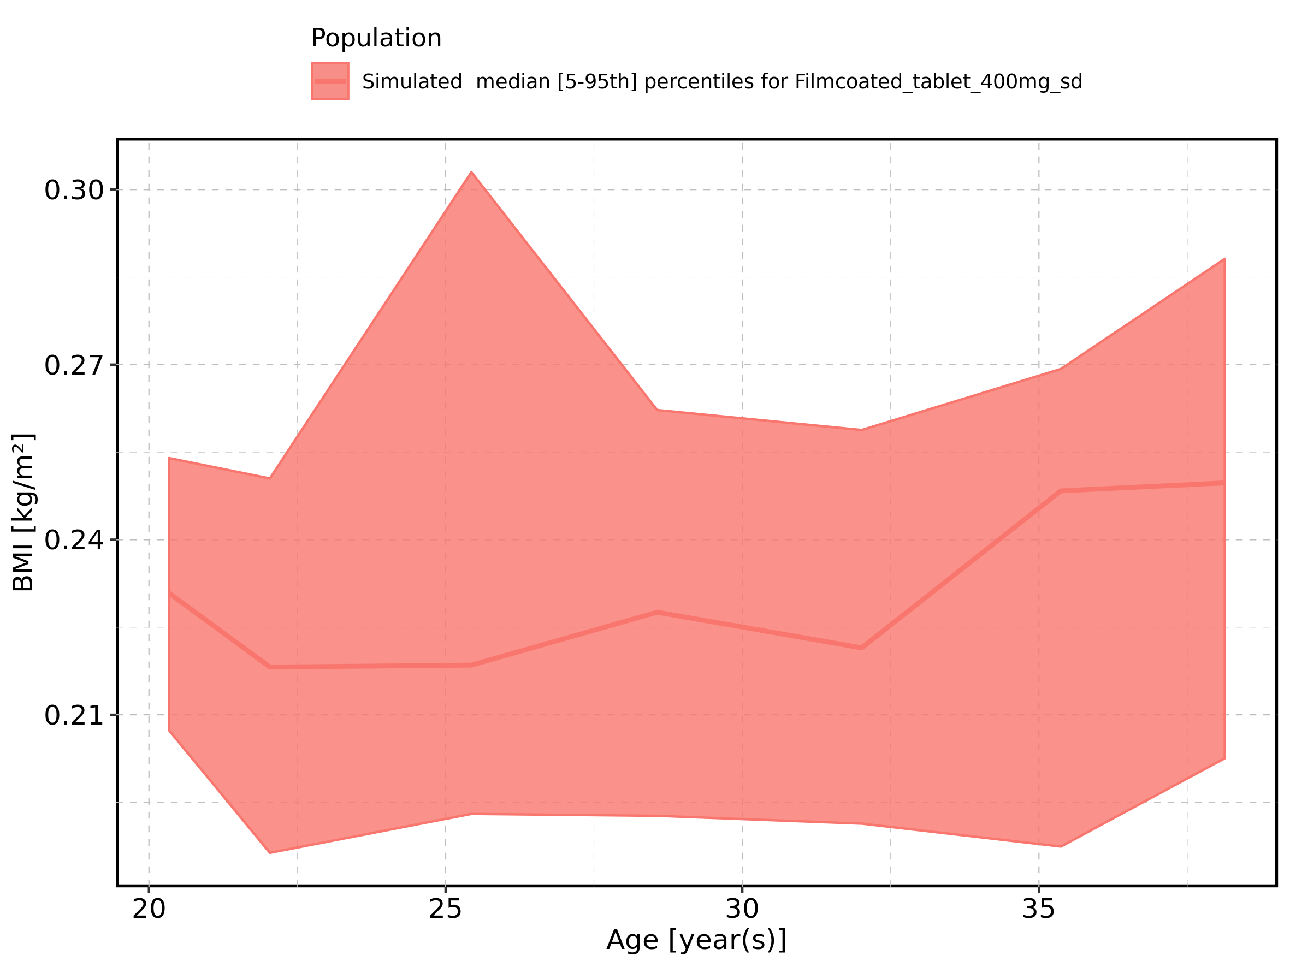

Figure 36: Age-dependence of BMI for Filmcoated_tablet_400mg_sd. Profiles are plotted in a logarithmic scale.

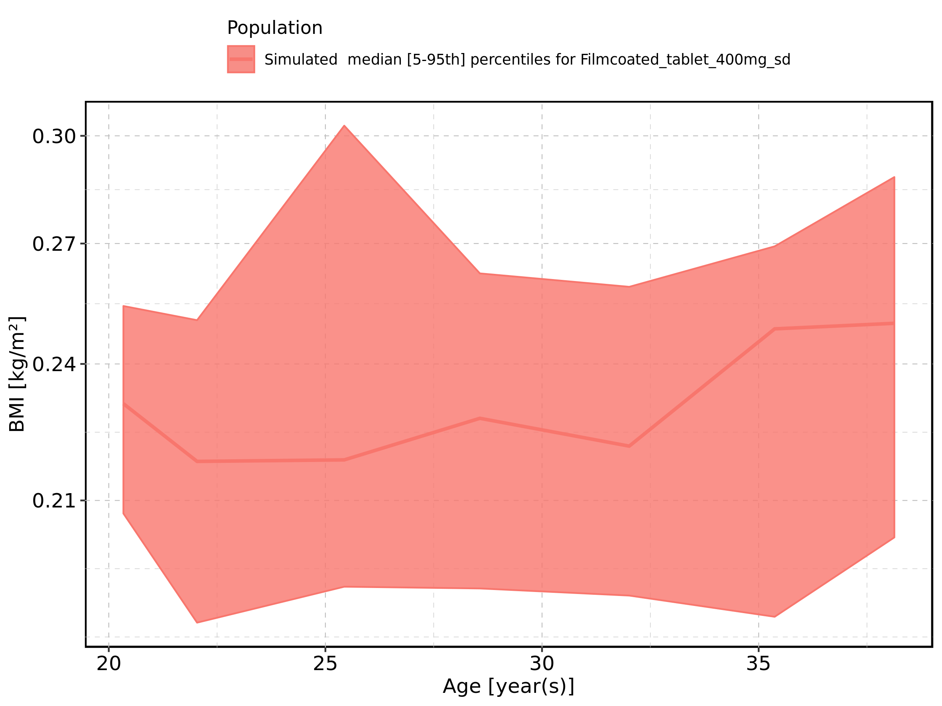

Figure 37: Age-dependence of Gender for Larson 2013 8y-18y 400mg FCT meal in comparison to Filmcoated_tablet_400mg_sd. Profiles are plotted in a linear scale.

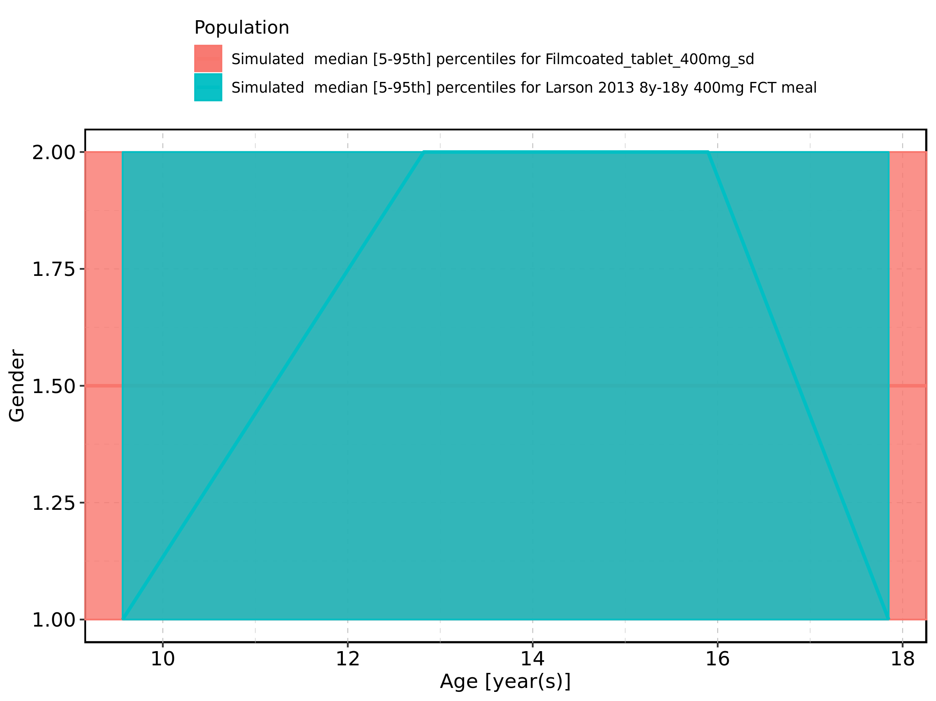

Figure 38: Age-dependence of Gender for Larson 2013 8y-18y 400mg FCT meal in comparison to Filmcoated_tablet_400mg_sd. Profiles are plotted in a logarithmic scale.

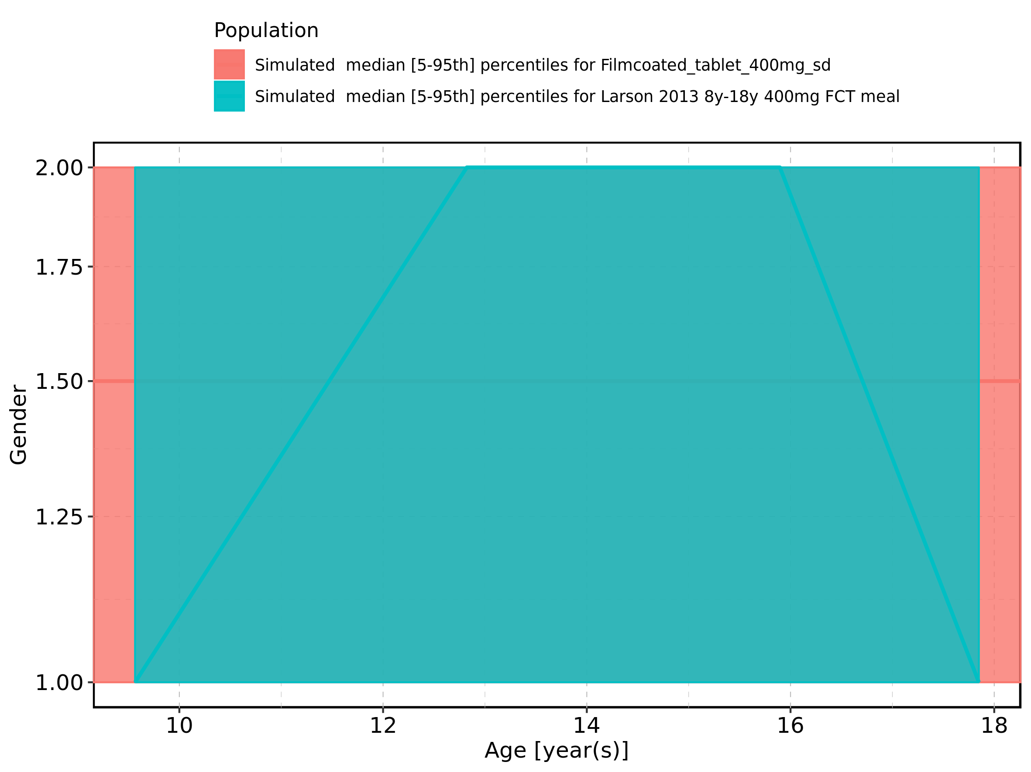

Figure 39: Age-dependence of Gender for Larson 2013 8y-18y 400mg FCT meal. Profiles are plotted in a linear scale.

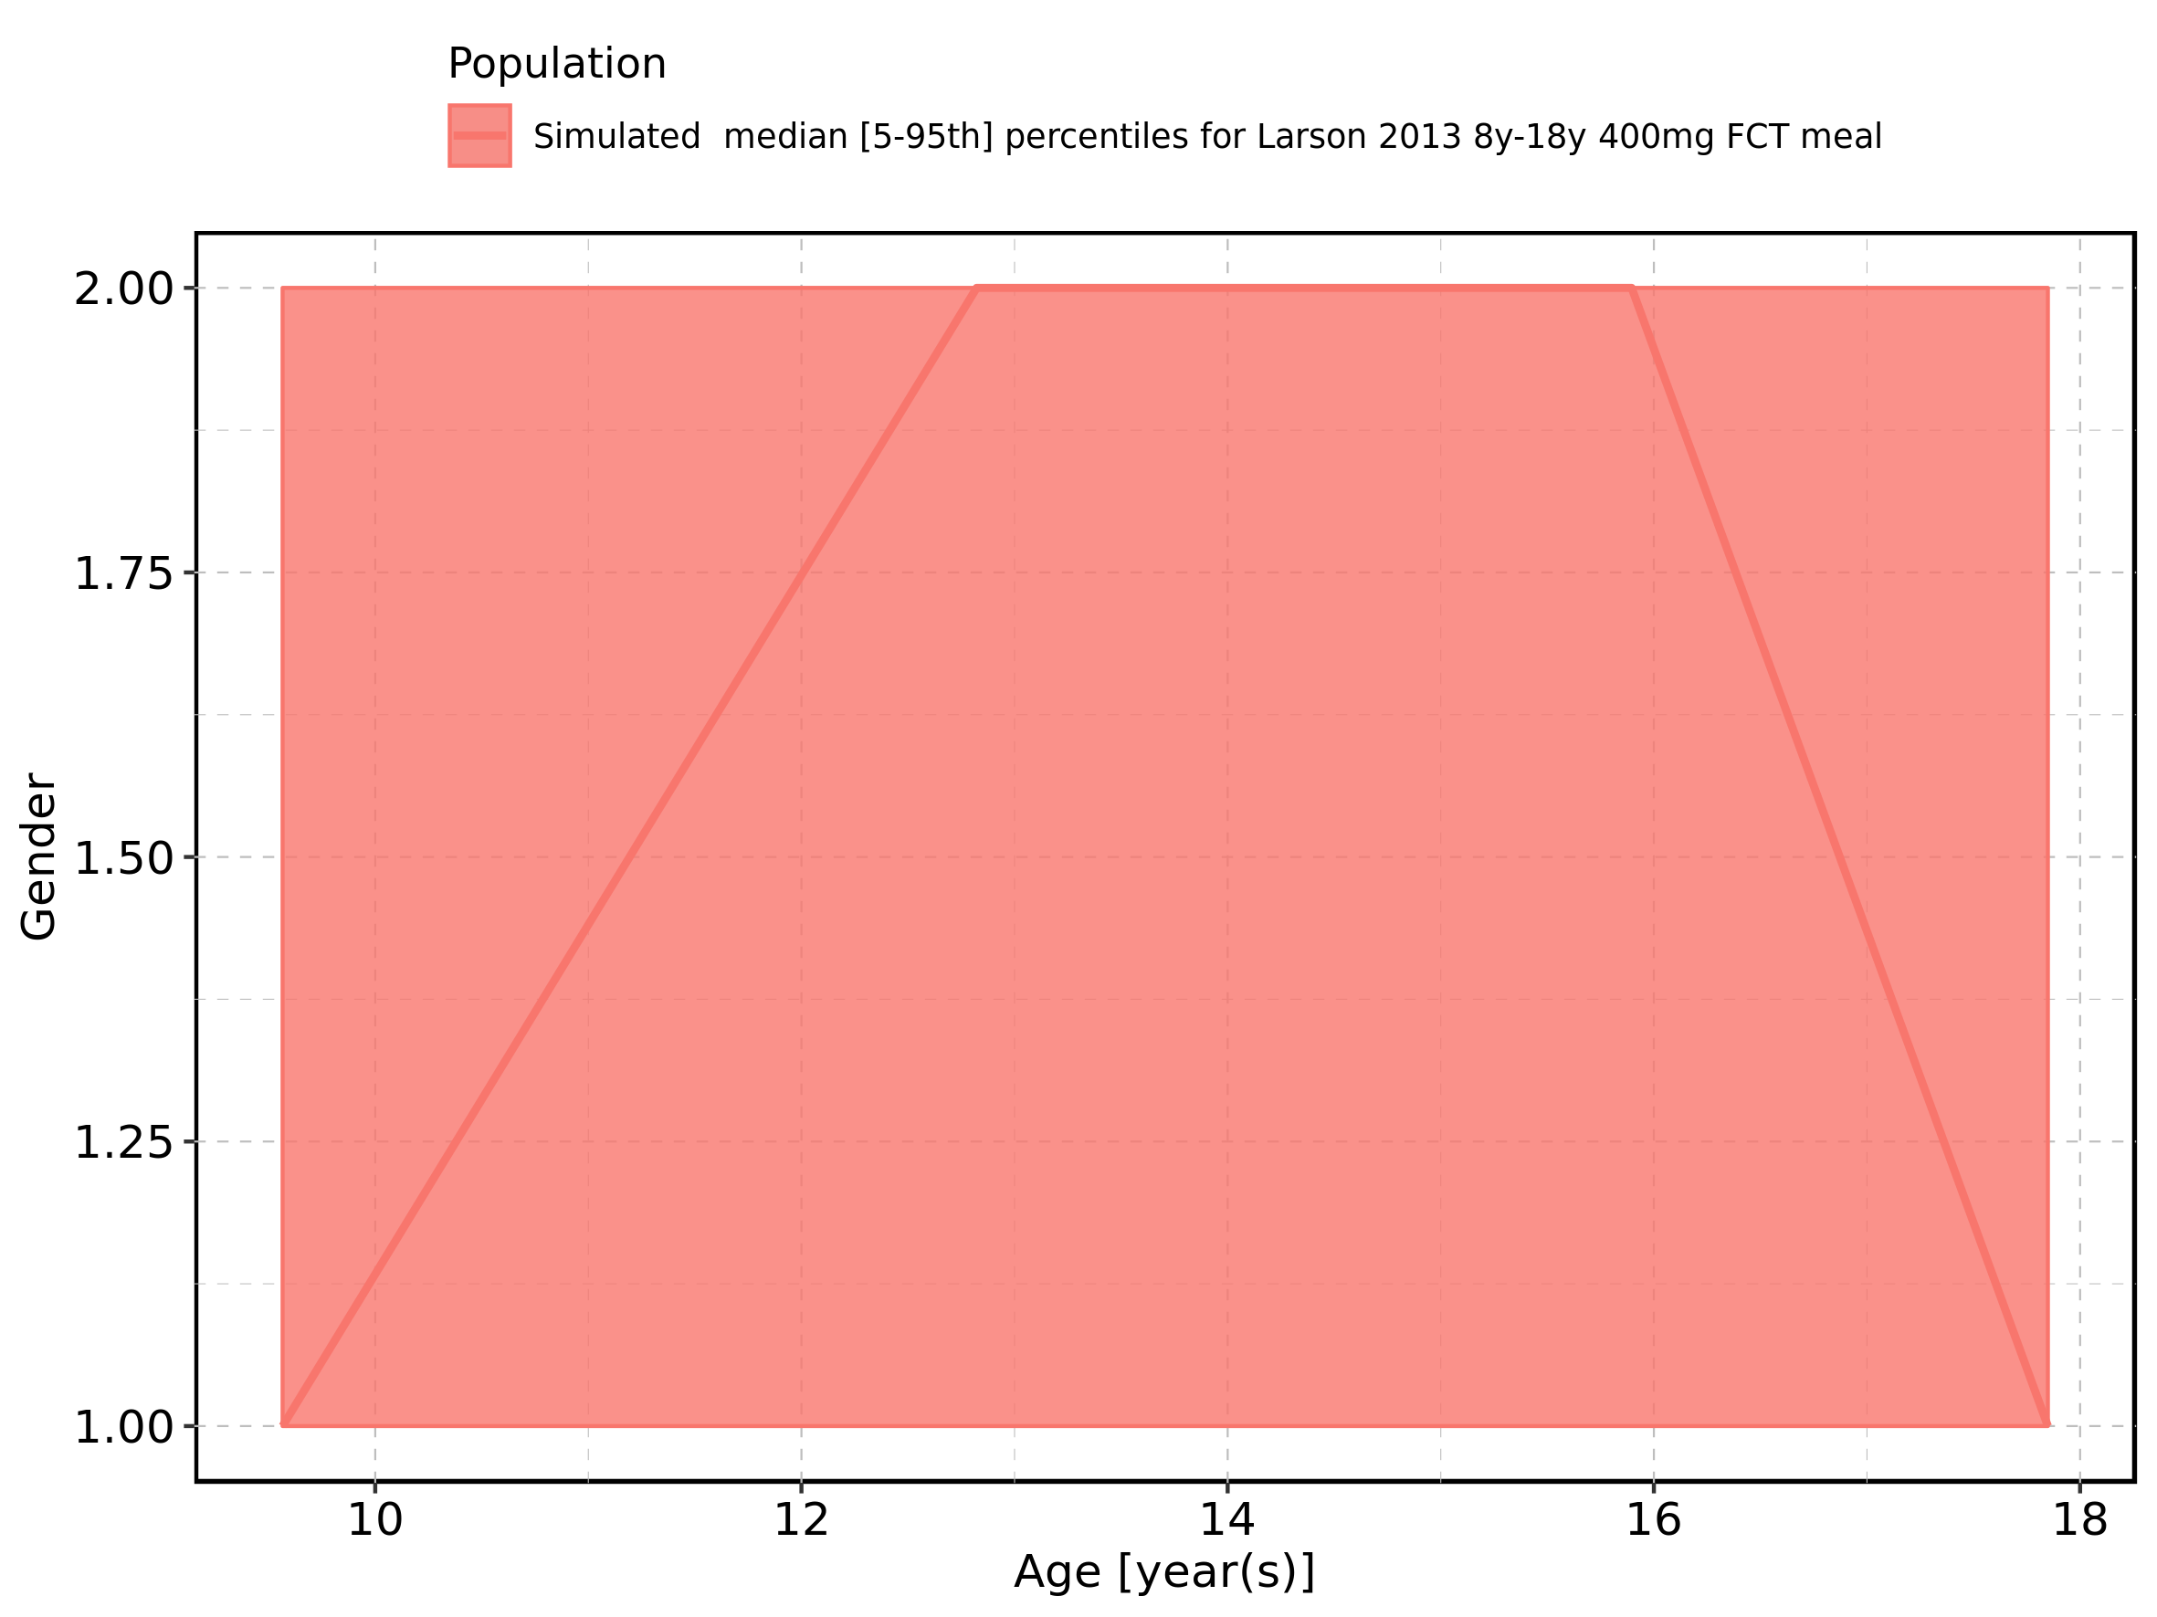

Figure 40: Age-dependence of Gender for Larson 2013 8y-18y 400mg FCT meal. Profiles are plotted in a logarithmic scale.

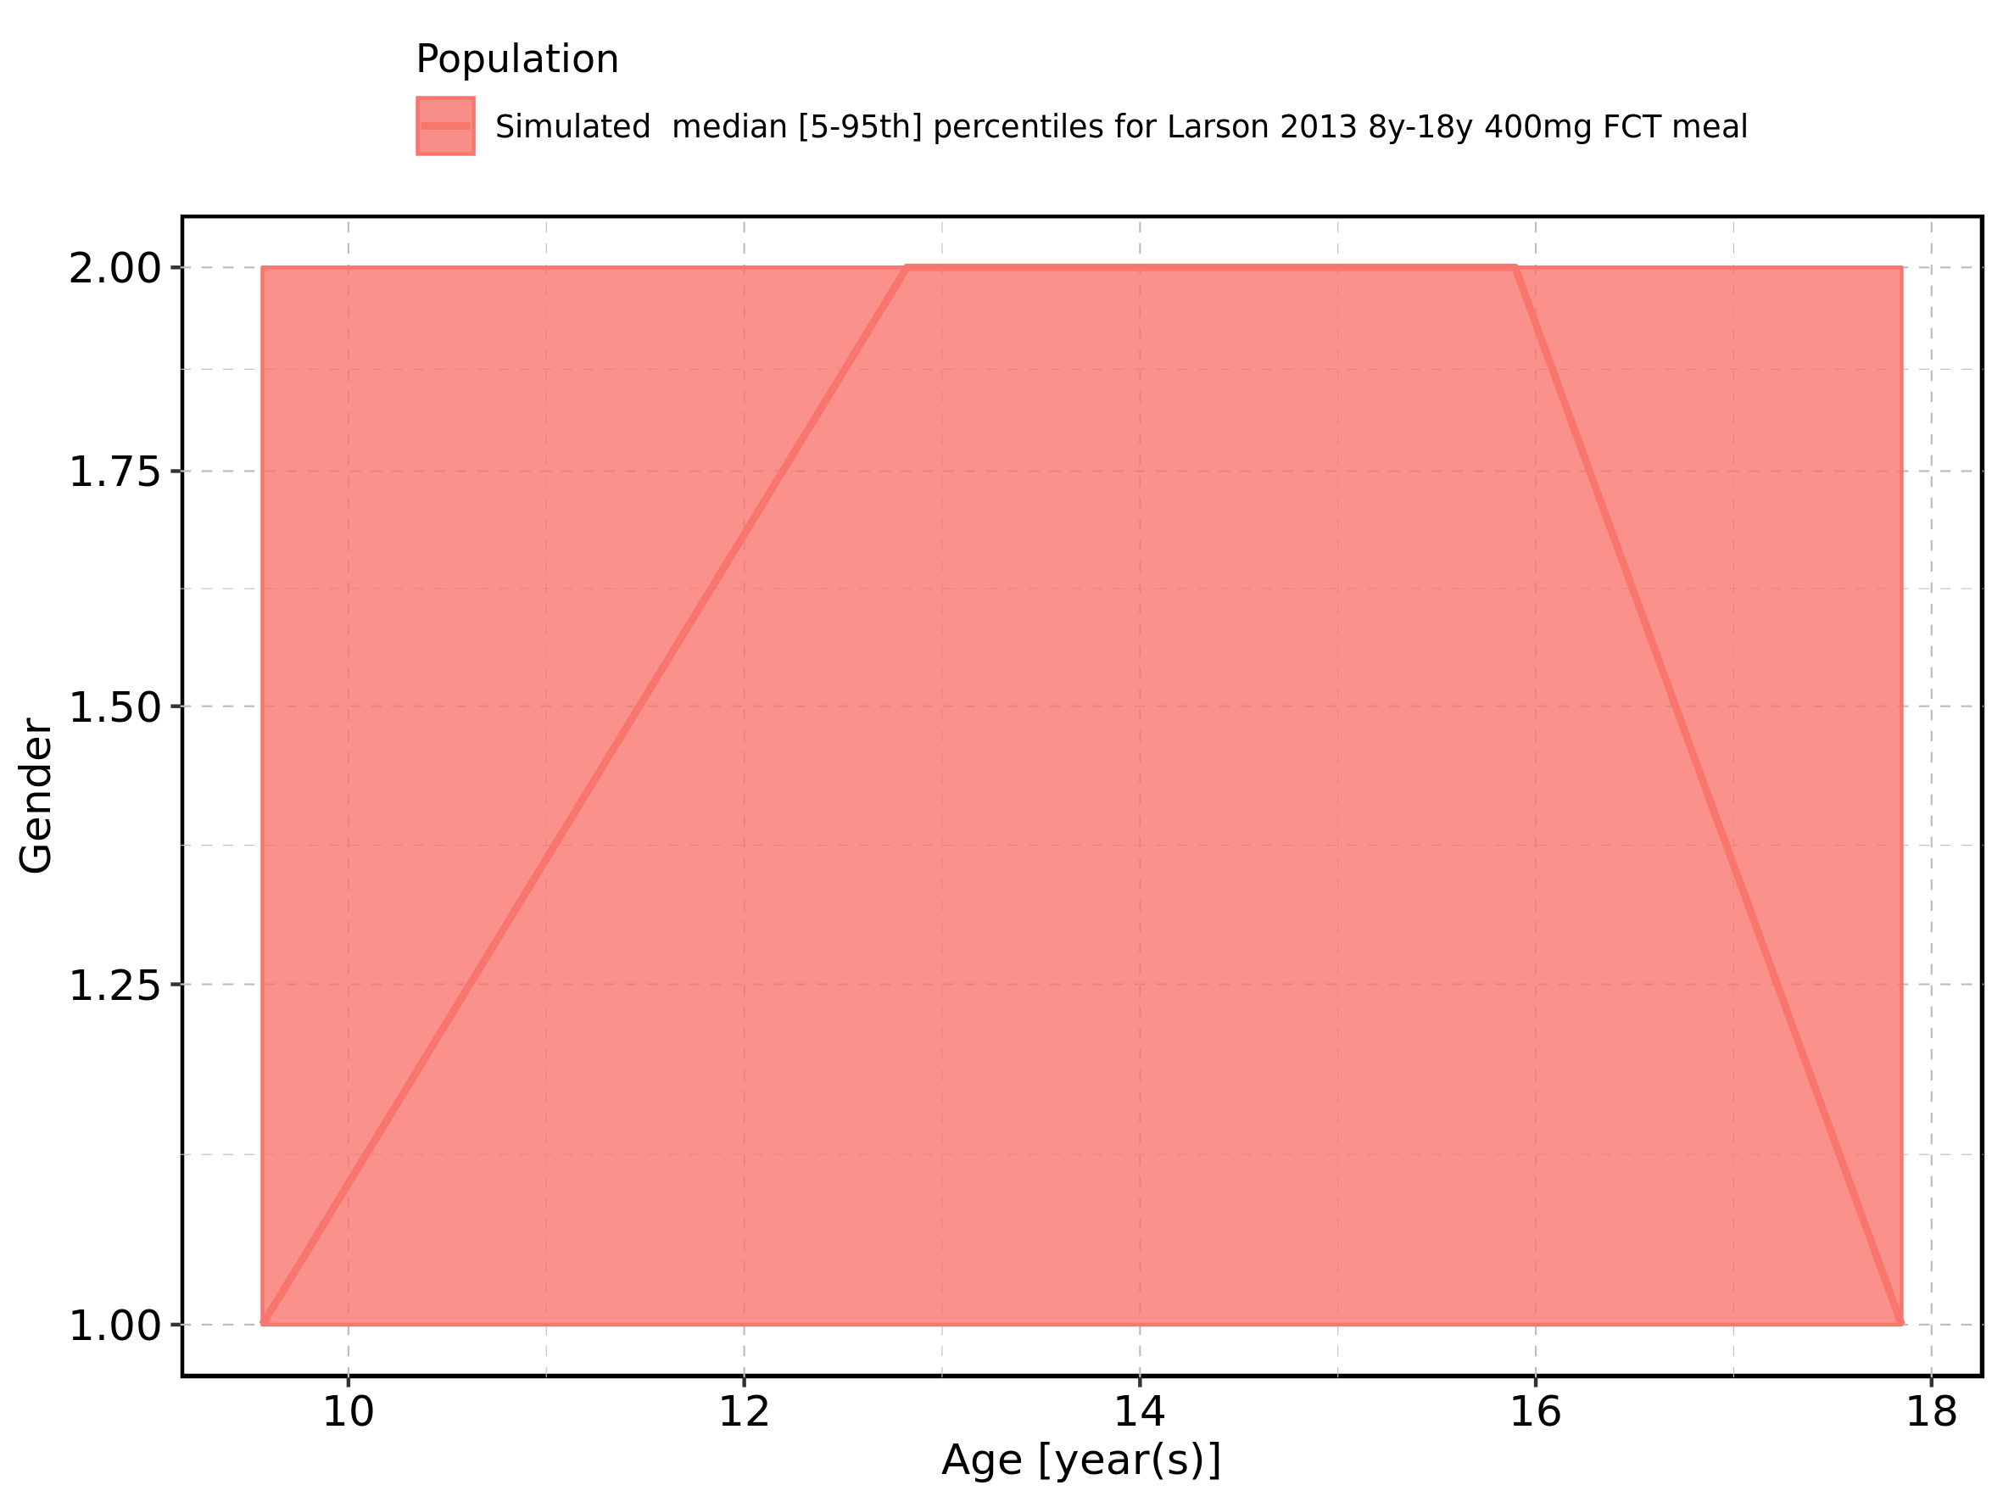

Figure 41: Age-dependence of Gender for Filmcoated_tablet_400mg_sd. Profiles are plotted in a linear scale.

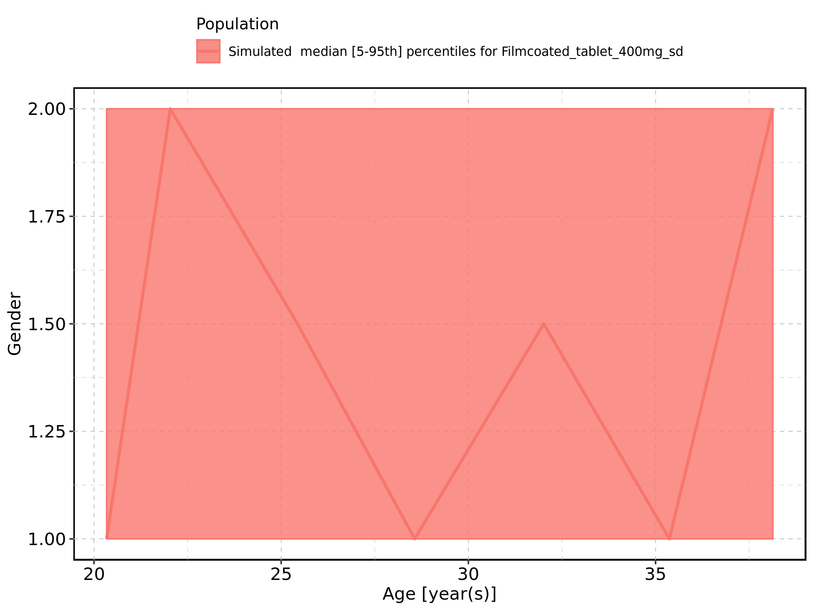

Figure 42: Age-dependence of Gender for Filmcoated_tablet_400mg_sd. Profiles are plotted in a logarithmic scale.

